NEA Project Report

Luis Goncalves

Centre Number –

Candidate Number –

( Alien’s Adventure Home ) Game

TABLE OF CONTENTS

ANALYSIS 4

An outline of the problem 4

Stakeholders 4

How the problem can be solved by computational methods 5

Thinking abstractly 5

Thinking ahead 5

Thinking procedurally 6

Thinking logically 7

Thinking concurrently 8

Conclusion 8

RESEARCH 9

Interview with Rui Goncalves to get an idea of initial requirements 9

Interview script 17/10/23 10

A review of the interview 17/10/23 answers 12

Research into “ Super Mario Bros “ 12

How do the different features effect the gameplay of “ Super Mario Bros “ 17

The features that will be used for the game 18

Interview 21/10/23 plan 18

Interview script 21/10/23 19

A review of the interview 21/10/23 answers 22

Features of the proposed solution 23

If original features are completed 24

Hardware and software requirements 25

Success criteria 26

DESIGN 30

Systems diagram 30

Explanation of each module 31

Usability / Accessibility features 35

Classes 37

Algorithms 38

Linking the algorithms 68

Key variables and data structure 69

Test data 74

Acceptance testing 79

DEVELOPING THE CODED SOLUTION “DEVELOPMENT DIARY” 83

Asset creation 83

Date : 10/11/23 83

Testing animation and world creation 85

Date: 12/11/23 85

Start of code creation 87

Date: 14/11/23 87

Coding the character 88

Date: 17/11/23 88

Character gravity 91

Date: 20/11/23 91

Animation and problem fixing 93

Date: 7/12/23 93

Problem fixing continued and cmaera placement 95

Date: 13/12/23 95

EVALUATION 98

Testing for evaluation 98

Usability features 108

Navigation 108

Controls 108

Screen elements 108

How well does the solution match the success criteria 109

Maintenance 117

Limitations and how they would be approached 117

PROJECT APPENDIXES 118

Code listing 118

# ANALYSIS

## An outline of the problem

For my project I am planning to create a game that is similar to ‘Nintendo : Super Mario ‘. This is a retro 2D platformer game where the user has to get the character ‘ Mario ‘ past the enemies and to the end of the level. There may be boss enemies that work differently to the normal enemies that the user encounters. Also, if the enemies can get to the user the character will lose a health point. If the character is able to get to the end of the level it will have an ‘ end level ‘ screen and once completed the game have an ‘ end game ‘ screen. However, if the enemies are able to damage the character enough for them to have 0 health, they will instead have a ‘ game over ‘ screen and then be taken back to the start of the level. There will also be a points system for what the character has done within the level to see how well the user passed.

For this to work, the game will require ; a starting point to the game, an end point for the level to finish, the user to move the character, enemies that can damage the character and a special / boss enemy that works differently to the other enemies. These are all that’s needed within the game, but more details will be added when creating the game.

## Stakeholders

The graphics of the game will likely be cartoonish, this means it will not be associated with real life. There won’t be any audio within the game, not only does this allow anyone to play the game as there are no language barriers but this will also allow audibly impaired players to play the game the same way anyone else would play the game. This game will be mainly played on a PC using some of the keyboard buttons to move the character and the mouse click to interact with items. However, the majority of people do not own a PC , for that reason this game can be easily adapted to play on a phone. You would be able to put the movement buttons on the left-hand side of the screen of go left, right and jump and use the interact buttons on the right side of the screen allowing anyone on a phone to play it just as if it was a PC. Due to the previous factors the target audience for this game would be anyone aged 3-21. I have decided on a person to use as my target audience, Rui Goncalves. He is a fifteen-year-old student who has experience with playing video games. He has also played the ' Super Mario ‘ game and other games in that genre. This means he will know what to expect from the kind of game I am creating. I will also have regular contact with Rui Goncalves as I live with him. He will use this by playing the game and he could also get his friends to play the game to see how well they play the game compared to him.

## How the problem can be solved by computational methods

This problem is well suited for a computer as it uses computational methods, this is because of how easily a game can be abstracted from reality and how it can have multiple conditions that must be set. Creating the game also means I must think ahead as to what will happen later on during development and it would also have logical algorithms that can be created for the game scenario. I have given some examples for how the game is suited to be solved by a computer program because of those computational methods.

## Thinking abstractly

I need to decide what to include in the game as well as what is necessary and what isn’t necessary. Not only is this done to make the game simpler to create but it also means that the game will run smoother because there is less data that the processor needs to run during the game. This is why abstraction is perfect for this.

Abstraction for ‘ Alien’s Adventure Home ‘

* Restrict game to 2 dimensions
* Add cartoonish style instead of realism
* Remove all sound as its unnecessary for the game to run
* Add a points system to help give the player of how well they are doing

## Thinking ahead

This allows me to look ahead and know what I want. This helps create structure to create my project around as I know the future steps I need to make for my project to be success . This also makes it easier to find the solution to the problem as it’s worked on.

* Plan on using Defold as it’s a good software to visualise the game as it is being created
* Inputs for the game will be from the keyboard and mouse and be easily defined allowing them to be changed if needed
* Buttons within the game need to allow the user to move around the menu systems
* Score system should be included to show the user how well they are playing
* Enemies need to react to where the character is and decide on what to do
* End of level should take the user out of the level to play the next level

## Thinking procedurally

This is similar to thinking ahead as this gives the problem structure making it easier to work on. This is because it uses decomposition to break up the larger problem into smaller and simpler problems to make the whole process more efficient.

Procedurally breaking down the problem ;

Alien’s Adventure Home

scoring

character

game state

enemies

movement

points per objective

menu system

movement

star system

level

health

velocity

high score

start up

velocity

gravity

health

behaviour

game over

items

This game can be broken down into 4 separate sections by thinking procedurally, these need to be solved to have the game run and have basic functions.

Character :

This will determine how the game is played and how the characters will interact with the environment. This could be by differences in map causing the player to jump or fall or items throughout the game that the character can use to their benefit.

Enemies :

These are much like the character but determine the challenge for the user to beat within the game and changes the game from a walkthrough of a map to an actual game the user needs to think about to beat.

Game state :

These different game states will give some depth for the game as it will give the game structure. There will be a start-up screen to introduce the game; this will then switch to the menu screen where you are able to go onto the settings tab or play the game. Also, if certain conditions are met the game state will switch to game over.

Scoring :

This will give the game some sense of achievement and replay ability. Each level will have a separate score, anything the player does will have a score related to it such as eliminating an enemy. At the end of each map depending on your score you will get a rating from 0 to 5 stars. This will also be stored as a personal best allowing the player to come back and beat it.

## Thinking logically

This helps me think about how I could solve the logical aspect of my problem.

When the menu button ( e.g. esc ) is selected the game will switch to the menu game state. If an enemy is eliminated a branch will be activated meaning the enemy will disappear and points will be added to the users score. As the game is running there will be a constant iteration running, spawning new enemies and checking certain conditions which will cause a branch changing the game state to game over or level complete. There will be a constant iteration being run to check when an enemy is hit and eliminated.

## Thinking concurrently

This is useful for thinking about how to make my solution more efficient when the solution is in use. The game will be updating the location of the character and score whilst drawing the image to the screen at the same time.

## Conclusion

The previous examples have demonstrated that the features of my problem can be solved with computational methods making it suited for a computer program. These methods are useful for giving the problem some structure so it can be more easily solved therefore making the problem suited for a computer program. Using these computational methods I can use decomposition to make each small section of the problem easily solvable and then I can fit together all of the pieces to make a usable and enjoyable computer program.

If the problem is successfully solved using a computer program the stakeholder will be able to play a game where they get their character form the starting area to the end whilst eliminating enemies giving them a certain number of points that will be scored at the end of each level. This is aimed to be a form of entertainment for the stakeholder to use.

# RESEARCH

## Interview with Rui Goncalves to get an idea of initial requirements

Interview : 14/10/23 PLAN

This interview will be conducted to find the basic requirements for the project from the user. This will give a direction to what sort of game will be created.

The main three heading for this are : what makes a good game ; what kind of game do you want and what kind of visuals are wanted for the game.

I have constructed a range of shorter questions under these heading to explain every aspects of the main questions to make the requirements for the game as specific as possible.

Question layout :

What makes a good game ?

* Do sound effects affect your game experience ?
* Do you think visuals effect gaming experience ?
* Should a score system be included in the game ?
* How realistic should the game be ?
* For the ‘Aliens Adventure Home’ game, how many enemies should there be in each level ?
* For the Aliens Adventure Home’ game, how would you like to play and interact with the game ?

What kind of game do you want ?

* How do you want the game to play, like a side-scroll game or platformer game for an example ?
* What are your thoughts on competitive games ?
* Is replay ability something you would like to have in your game ?
* Would you like the game to store your overall high score ?

What kinds of visuals are wanted for the game ?

* If any realistic features should be included for ‘ Alien’s Adventure Home’ what would you want them to be ?
* What type of game style would you like ?
* What sort of theme would you like for the background of the game ?
* Would you want the backgrounds to change ?
* Would you want any animations for the moving targets ?

## Interview script 17/10/23

What makes a good game ?

Do sound effects affect your game experience ?

No, most of the time I’m listening to music whilst I play games and don’t even have the sound on anyway.

Do you think visuals effect gaming experience ?

Yes, depending on how the visuals look could definitely change how the user feels about the game, a Rated 18 game could have more gore than a rated 3 game although it doesn’t affect the gameplay itself.

Should a score system be included in the game ?

Yes, this will help the user see how well they did and increase replay ability as users could play the game over and over to beat their personal best score or their friend’s score.

How realistic should the game be ?

As I want the game to be more cartoony the game doesn’t need to be very realistic but I would like to feel as though the game could be real so the speed of characters and enemies and speed of gravity should be

For the ‘Aliens Adventure Home’ game, how many enemies should there be in each level ?

I wouldn’t want to be completely swarmed with enemies on each level however I think their should be enough enemies to not make the level feel empty. There should be enough enemies for the user to have a challenge but not so many that the game feels irritating.

For the Aliens Adventure Home’ game, how would you like to play and interact with the game ?

I would like to use the keyboard on my computer to control the character and its movement and use the mouse click button to interact with and use things.

What kind of game do you want ?

How do you want the game to play, like a side-scroll game or platformer game for an example ?

I’d like the game to play as a side-scroller over any other option because the game as its an adventure it would be good to show the character progression through the game until they reach the end.

What are your thoughts on competitive games ?

Although I’d like the game to be single player id still like a competitive part of it like if I were to compare how well I did to a previous attempt or how well my friend did at the game.

Is reply ability something you would like to have in your game ?

Yes, I think if there were a reason to play the game again and again it would make the full experience much more fun because you are able to go back and play the game in a different way or try to be better than a previous attempt.

Would you like the game to store your overall high score ?

Yes, I think having a score within the game and storing your overall score would be good as its an easy way to see how you did and how well you did in comparison to your friends when they play or against a previous attempt.

What kind of visuals are wanted for the game ?

If any realistic features should be included for ‘ Alien’s Adventure Home’ what would you want them to be ?

I’d don’t really mind about the visuals being realistic I like the cartoonish art style however id like some of the gameplay to be realistic such as the movement and jumping/gravity feeling real so it doesn’t look out of place if the character is moving too fast or jumping too high.

What type of game style would you like ?

I’d like the game to look cartoonish but I don’t want it to be too retro and pixelated as I feel it would make the game look weird.

What sort of theme would you like for the background of the game ?

I’d like to start out at some sort of countryside but I feel like it would be nice in one of the missions if there were to be a different background maybe being in a different location or showing that it’s a different time of day, id like to keep this with the theme of the cartoon format as it will all look better together being in the same style.

Would you want the backgrounds to change ?

Yes, I think maybe toward the end of the game it goes to night time or we could be in a different place at one part of the game like the sewers, it would show the user that the alien really is going on an adventure and isn’t just walking around the same place over and over.

Would you want any animations for the moving targets ?

Yes, I like when there are animations for actions such as movement because it completely ruins the game for me when there’s no animations it really looks cheap and unfinished when its just a non-moving photo of a character going across the screen.

## A review of the interview

## 17/10/23 answers

This interview was created to see what things the stakeholder wanted from the game to make it enjoyable for him. The stakeholder and I ended up concluding that the visuals are important when looking at the gameplay but in general it will make the game more unique.

For the visuals we decided to include some animations, but we will not be using any sound or sound effects throughout the entire game. Also all of the artwork will be in the format of a cartoon, the game will be realistic enough to that it feels believable to the player however because the game is a cartoon it doesn’t have to be very realistic which means there won’t be any gore within the game.

For the gameplay, we decided to include a level system that will link in with a scoring system from each level that will give the overall score of the run. This is to give the player a sense of achievement further than just completing the game and will also give the player reason to keep replaying the game or play as well as they can to see if they can get a score higher than someone else such as one of their friends. This will make the game more appealing to a wider audience as there are lots of people who wont just play a game on their own they enjoy more of a challenge such as competing against a friend. Finally it was agreed to specify the game to be played on a computer and not only use the keyboard for controls but also use the mouse for other controls for the character.

## Research into “ Super Mario Bros “

“ Super Mario Bros “ is a platform game developed by Nintendo, where the user must go from the left to the right to finish the level at the flag. Throughout this the user encounters different enemies and different terrains within each level. The game is from a perspective away from the character however it follows them across the screen from left to right. This game has different controls for going left, right and jumping.

The game has different levels, these differentiate the environment and in some levels there are even different enemy types. Each level has a different environment within Mushroom Kingdom that Mario has to get to the other side of. The user will get points added to their score from the amount of enemies that they defeat and at the end of the level the amount of time left they have on the clock is also added to their score.

Within each level the user has a certain amount of lives for the character before they have to restart the level, more lives can be gained after each levels and within each level if they get the right power up. This gives the game more depth of play and doesn’t mean you reset every time the character is eliminated and start from the start again. At the end of each ‘ world ‘ or area within the game there is a boss or mini boss that is different to the other enemies that the user must defeat to progress along toward the next area.

Main features of the game include :

These are examples from Super Mario Bros of some features that I believe I would be able to incorporate into my project to enhance the gameplay for the user. These would not be the same as seen here but would be “ Alien’s Adventure Home “ own version of these features.

Time limit for each level, this is important as it shows the user how long they gave left

The amount of lives the character has left, this is important for the user as it shows how many times they can be defeated before having to restart

Gameplay

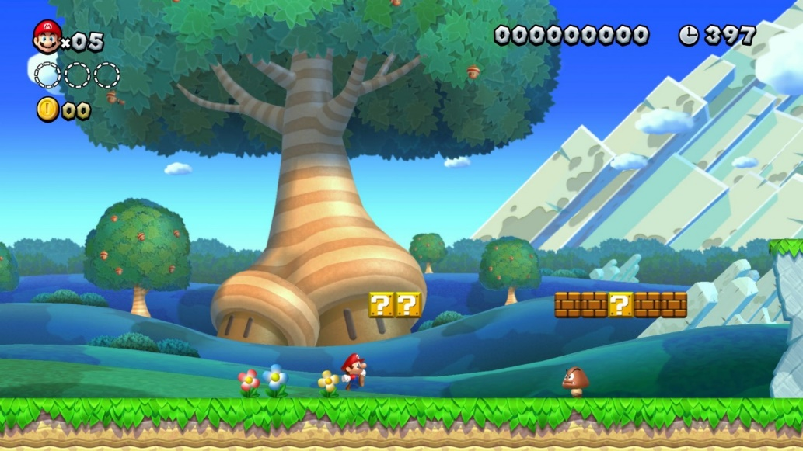

Score calculated throughout and after each level, this is needed to show the user if they are doing well

Character the user controls throughout the game, this is needed as it shows the user what they are controlling

Enemies the user has to face throughout the game, this is important as it gives the user a challenge

Terrain the user can run across throughout the game, this is important as it shows the user where to go

Animations for running and jumping etc, this is added to enhance the experience for the user

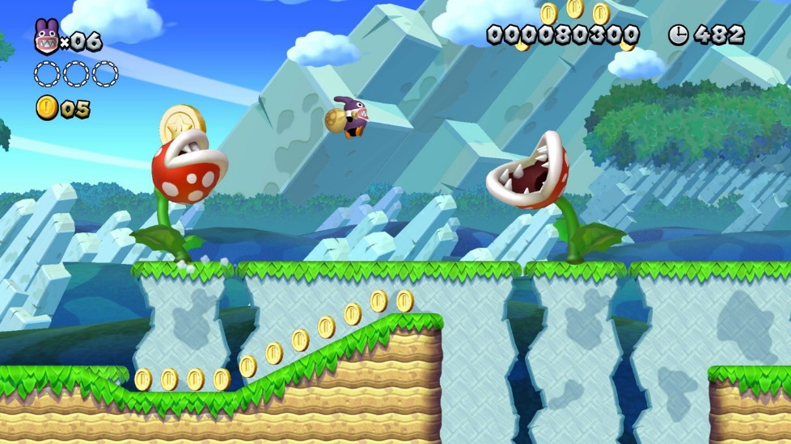

Different enemy types within the game to differentiate gameplay for the user

More terrain differences the user navigates across, this helps to differentiate the game for the user

Different enemies have different behaviour within the game, important to differentiate the gameplay

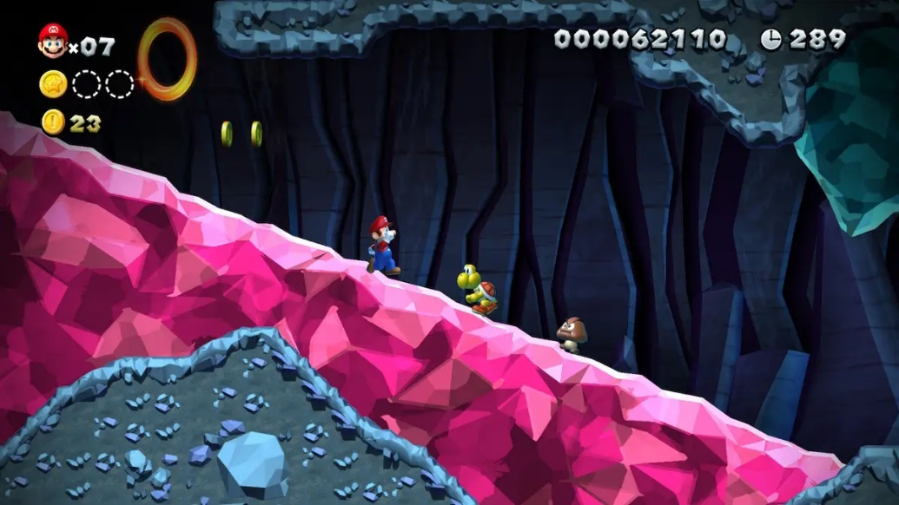

Different environments the player goes through in each level, this is important to show the user the progress they’ve made

This certain enemy follows the character until they’ve been eliminated or out of range of the character

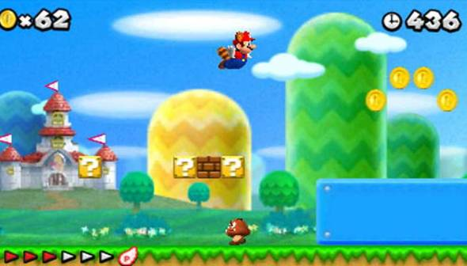

There are different powerups that the user can pick up, these gives the character special abilities or lives. These are important because it changes the way the user plays the game

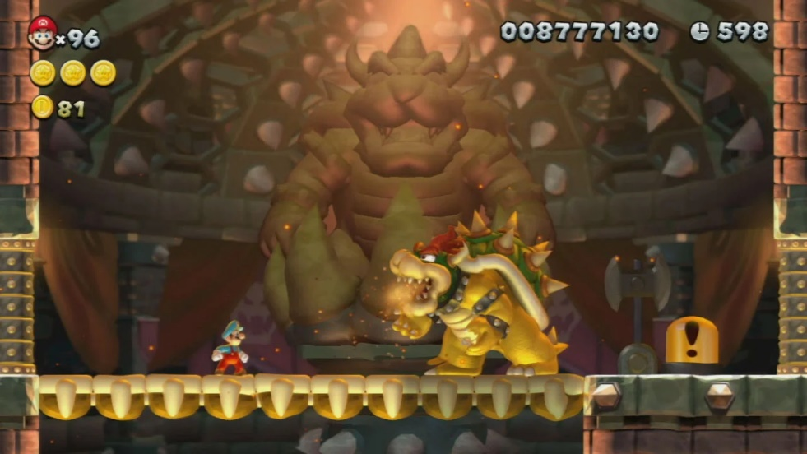

At the end of each ‘world’ or group of levels there is a special level which includes a boss which plays different to other enemies and is harder to defeat. This is important as it gives the user completion once ending the game

This is the boss at the end of the game and must be defeated for the user to finish the game

Checkpoints / Saving

Score stays on the screen during the entire game and goes up in real time as the user gains more points, helps to show in real time when the user does something good

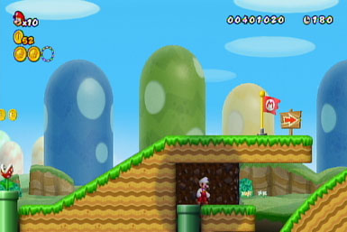

This is a checkpoint at the middle of the level that lets you respawn there if the character gets defeated, important to help the user play the game

When you’ve touched the checkpoint, you are also able to completely leave the game and when you come back you will start from the checkpoint instead of the start of the level, important to help the user

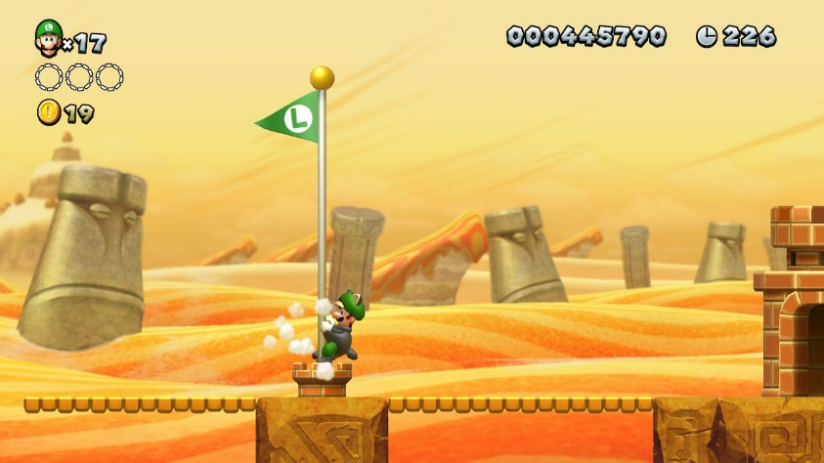

Also gives the user a certain number of points added to their total depending on how high up the character touches the flag, to show the user how well they did

This shows the user it’s the end of the level and ends once the character touches it. This is important so the user knows where the level ends

Once the character has touched this point, they are invulnerable to damage and all enemies around disappear, this is important, so the character isn’t defeated after game end

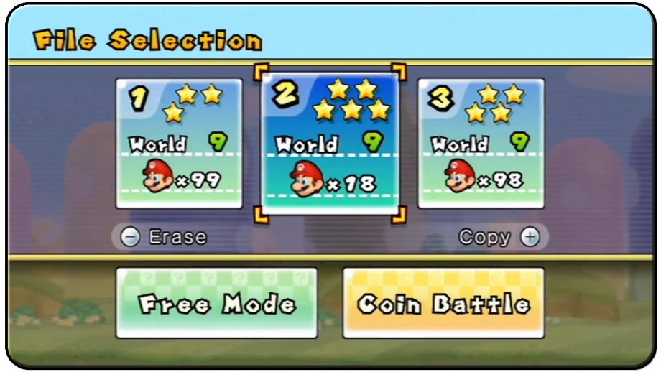

This also allows you to have multiple saves that you can switch between at any time within the menu, this is important if more than one person wants to play, or the user wants to play in different ways system

Menu System

Start a new game from the start, this is important to show the user where to start

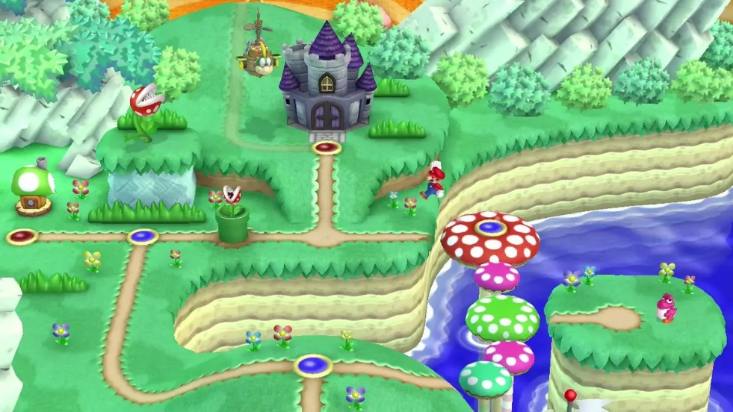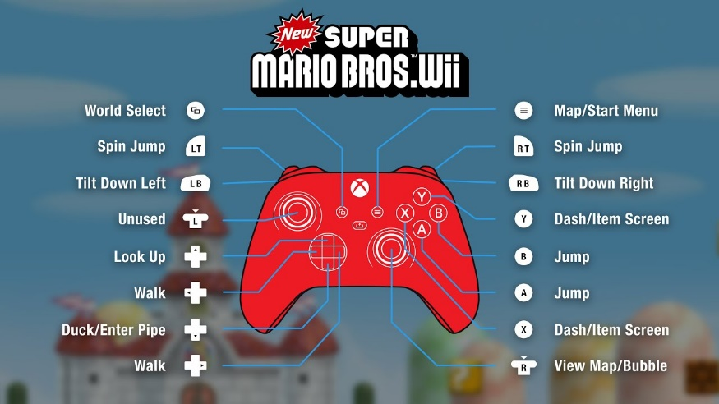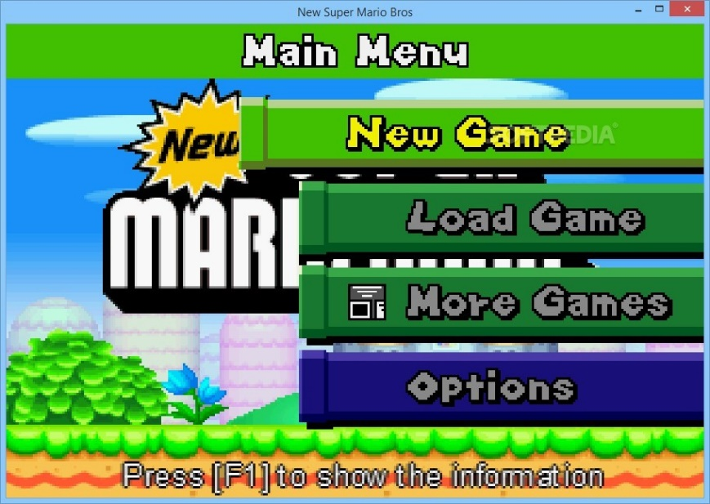

Blue means the level has been completed and red means the level hasn’t been completed yet, this is important to show the user what they must complete

Options menu to change settings such as controls, important to allow the user to customise the game for themselves

This shows the user which level they have completed and what levels are upcoming, this helps to show users what to do next

This shows the controls, where each button is and what each button does, this is important to show the user where each control is

This is the setting to change the controls within the game, this is important for user customisation

Menu system to navigate the game, important for the user to find what they need

Load an old game from a save beforehand, important to be able to play other saves

## How do the different features effect the gameplay of “ Super Mario Bros “

Lives

The life system shows the player how many times they can respawn within the game before they have to go out of the level and recharge their lives, when defeated they go down, but the player also has the ability to gain lives within the level from some power ups.

Time

Having the timer on screen shows the user how much time left they have to complete the level, although most of the time this timer doesn’t get near 0 it is also added onto the score at the end of the level. This matters to the user as they are trying to get the highest score whilst completing the level.

Score

Having the score system and having it change in real time on the screen for the user shows the user when they are doing well and helps the user to see what to do as when they do things the game wants them to do such as defeat an enemy it goes up helping the user.

Terrain

Having different kinds of terrain within the game gives the user something fresh to look at instead of running through levels that all look the same. Aswell as this different kinds of terrain can give the user different challenges as they have to navigate each level.

Different enemy types

Having different enemy types within the game helps to keep it feel as if you aren’t doing the same thing over and over. With different types of enemies, the user has to think of different ways to defeat them or get past them if they can’t be defeated.

Boss enemy

Having a boss enemy at the end of the game helps the user to feel accomplishment and has it as a final challenge for the user to defeat to finish the game, this is also different to any other enemy within the game which makes it a challenge

Checkpoints

Having a checkpoint in the middle of the level helps the player, it allows the player to respawn at a halfway mark instead of at the start of the level. Not only does this help the user finish the level but it also gives them something to achieve when they start each level

End point

This gives the user a clear end to each level, it also gives the user a sense of accomplishment as it’s such a big flag. Because the player can get more points the further up the flag they hit it gives the user a little game once the level is over as well.

## The features that will be used for the game

## Interview 21/10/23 plan

This interview will give more specific requirements linking to the game visuals; game play, level system and menu system. This interview will allow me to create my first set of requirements suitable to allow me to start solving the problem.

Question layout :

Visuals

* What animations do you want for the character ?
* What animations do you want for the enemies ?
* Do you want an animation for the end of the level ?
* What sort of theme do you want for the game ?
* Do you want the points to appear above a target when defeated ?

Game play

* How many enemies do you want on the screen ?
* How many different kind of enemies ?
* How would you defeat the enemies ?
* How would the enemies defeat you ?
* Would you like to have a halfway checkpoint ?
* Would you like your lives to be shown at the top of the screen ?
* Would you like to have a timer
  + If yes, do you want it linked to the points system ?
* Do you want a final boss enemy ?
  + If yes, would you also like a mini boss part way through the game ?
* Do you want a menu button ?

Level system

* Would you to physically see you go from level to level ?
* Do you want each level to look different / have a different terrain?
* Would you like your score to carry over from each level for an overall score ?
* Would you like a scoreboard ?

Menu system

* Would you like the options to be part of the menu ?
* Would you like to change controls and settings within the options ?
* Would you like accessibility features to be added to the settings ?
* Would you like to start new games / load games from the menu ?

## Interview script 21/10/23

VISUALS

What animations do you want for the character ?

I would like the character to have a moving and jumping animation, but I’d like to be sort of basic so it’s easy to understand what the character is doing

What animations do you want for the enemies ?

I’d like the same animations for the enemies as the character so moving and jumping so all the animations are similar

Do you want an animation for the end of the level ?

I’d like a small animation for the ending of the level to show its complete such as the character walking to the side of the screen to show they’re progressing to the next area of the game

What sort of theme do you want for the game ?

I’d like the game to start in a town or meadows and as you get closer to the end it gets darker like brick and swamps and maybe the time of day changes to evening then night as well to signify that you’re getting close to the end of the game and it will be more difficult

Do you want the points to appear above a target when defeated ?

I don’t want the points to appear above an enemy when they are defeated because I feel like it will clutter the screen and bring the user out of the game id like if they were to just be added onto the score that stays at the top of the screen out of the way of the main action

GAME PLAY

How many enemies do you want on the screen ?

I’d like there to be some enemies on the screen at any one time and as you get closer to the end of the game there are more making it more difficult but I don’t want the game to feel cluttered with enemies

How many different kind of enemies ?

I’d like there to be a variety of enemies but I’d like it to progress as you play like having one enemy type that’s the easiest to defeat first then adding a new one that’s it’s a bit harder later on then once you get near to the end of the game have a final enemy type that’s most difficult to defeat

How would you defeat the enemies ?

I think it would be funny for the character to jump on the enemies heads, but I’d also like the character to defeat them easily with any power up they have to really show how powerful the power ups are

How would the enemies defeat you ?

I’d like the enemies to defeat the character if they were to just walk into them at all, but also if they have a projectile they throw at the character that could also defeat them

Would you like to have a halfway checkpoint ?

I think it would be nice to have a halfway checkpoint in the game to show the user how far they’ve come, also it’s a good place to respawn so the user doesn’t get frustrated if they have to keep respawning again and again from the start of the level

Would you like your lives to be shown at the top of the screen ?

Yes, I think it’s good that the user can see how many lives they have left so they know if they should play the game more carefully if they have low lives or try new things when they have lots of lives to fall back on

Would you like to have a timer

Yes, I think it’s good to have a timer in the corner of the level even if it’s so long that it doesn’t push the user to play the game quicker but just means you can’t stay there together as it would help with the fact that the character wants to go back home from their adventure

If yes, do you want it linked to the points system ?

I think it would be nice if at the end of each level the time left is added onto the total score from the level to reward people for completing each level quickly

Do you want a final boss enemy ?

Yes, I feel like a big final boss to complete the game with would be a good way to finish of the game and it would help and make sense to why the enemies are there and why it gets more difficult the further through the game you go

If yes, would you also like a mini boss part way through the game ?

I feel like it would be good to have a mini boss that’s a bit easier than the final boss some part through the game to introduce the user to boss type enemies before they have to face off against the final boss and it would help with the story telling of the game

Do you want a menu button ?

I would like to have a menu button but wouldn’t want it to be a button in the game that you can see whilst you’re playing I would rather it be a button the user presses and then the menu shows up and the game is paused whilst you’re in the menu system. I would like you to be able to open the menu whilst you’re in a level instead of only outside the level

LEVEL SYSTEM

Would you to physically see you go from level to level ?

I’d think it would look nice if you were to see the character go form level to level however it doesn’t need to be to in depth as it isn’t the core gameplay at all so it could even be a dot going from one place to another

Do you want each level to look different / have a different terrain?

I wouldn’t want each level to look the exact same, but I don’t want each level to look different it would look nice if each level blended into the next to show the adventure the character is on instead of the character just disappearing to a new area once a level is over

Would you like your score to carry over from each level for an overall score ?

I’d like the score to carry on from level to level to see your overall score at the end to see how well you did overall and you are able to challenge your friends scores against yourselves to see who is better

Would you like a scoreboard ?

I would like for there to be a scoreboard you could do it from old levels from each level or high score from your overall score against other save files

MENU SYSTEM

Would you like the options to be part of the menu ?

I’d like the options to be part of the menu id like it all to be in the same area and you can access it all really quickly and simply making it easier for the user

Would you like to change controls and settings within the options ?

I think it would be good for people to be able to change the controls and settings within the options by having a settings button within it, this would help people find all the things in one place and is easily accessible for anyone

Would you like accessibility features to be added to the settings ?

Yes I feel like accessibility features would be good such as being able to change the controls for people who need different controls or being able to support 3rd party controllers for people who aren’t able to use a keyboards and mouse

Would you like to start new games / load games from the menu ?

I think the option to start a new game or load a new game from the options would be good, but I’d also like to be able to start a new game / load a new game from the main menu when you first load into the game

## A review of the interview 21/10/23 answers

Through this interview the main features of the game have been established

Visuals

* I want moving and jumping animations for both the character and the enemies
* I want an animation for the end of the level to show the user that the level is over
* I’d like to start the level in somewhere nice like a meadow and move somewhere darker as the game progresses like a sewer as the game gets harder
* I don’t want the points for eliminating an opponent to show up on the screen because it would clutter the screen so it should just be added to the score at the top

Game play

* I don’t want there to be too many enemies on screen at one time, but I want the game to get harder as I progress through the game
* I want there to be different kinds of enemies in the game ranging from easier enemies nearer the start of the game to harder enemies nearer the end of the game
* I’d like to defeat the enemies by jumping on their head which would instantly defeat them
* I would like the enemies to defeat the player if they were to touch the player
* I’d like there to be a halfway checkpoint in the game that the character can respawn at once they’ve crossed the halfway mark
* I’d like the amount of lives the character has got to be shown at the top of the screen to show the user how many lives they have left
* I’d like there to be a timer to show the user how much time they have left to complete the level
* I’d like the timer to be linked to the points system to reward users who can finish the game quicky
* I’d like their to be a final boss to show the user where the story is going and close the game out with a final fight
* I’d like their to be a mini boss that is a bit easier to defeat to introduce the boss type of enemy to the user
* I’d like there to be a menu button as a button on the keyboard you have to press instead of a physical button within the game

Level system

* I’d like to see the character go from level to level physically but it doesn’t need to be in depth as it isn’t a core aspect of the game
* I’d like the terrain of each level to be different but for them to blend into each other to show it’s a continuous adventure
* I’d like the score to carry over from each level to see a complete overall score once the game is over
* I’d like their to be a scoreboard system within the game to see how well you did against your friend or how well you did against other personal best times

Menu system

* I’d like the options to be part of the menu system, so it is all in one location so it’s easy and accessible for the user
* I’d like to be able to change the controls for the character and other settings within the menu system under the options button
* I’d like accessibility features to be added to the game like supporting 3rd party controllers
* I’d like to be able to create / load new games from the menu but also from the main menu when loading into the game

## Features of the proposed solution

These are the main proposed features for the game :

|  |  |
| --- | --- |
| Movement animations for character and enemy | This gives the character and enemy animations for moving from side to side and jumping |
| End level animation | This gives the user an animation to show that they have completed the level |
| Background progression | This goes from nice like a meadow and gets darker and creepier as the game progresses ending in somewhere like a sewer |
| Terrain progression | This follows the background as it goes from grass such as in a meadow to darker such as stone bricks to show the character is in a sewer |
| Point system | This is to help the user know what to do and goes up when eliminating an enemy to see how well you did |
| Point overall | This is all the points from each level added together at the end of the game to see how well the user di overall |
| Scoreboard | This is to see different users or game saves overall score against each other to see who did best |
| Timer | This is shown on screen to see how long left the user has to complete the level |
| Timer linked to points | Once the level is over the time is added onto the score to reward players for finishing quickly |
| Life system | This is shown at the top of the screen and shows the user how many lives the character has left until they have to replenish them and start the level again |
| Power up / life up | This is something the character can gain within each level, it could be either something that helps the character defeat enemies or extra lives for the character |
| Amount of enemies | There will be a pre-determined amount of enemies in each level as to not make the level to hard or clutter the screen |
| How to eliminate enemies | Each enemy will be eliminated by jumping on their head, this means it isn’t too violent / graphic |
| Final boss | At the end of the game the final mission will include a final boss the user must defeat to finish the game |
| Mini boss | This is an easier boss part way through the game that introduces the boss type enemy before the main boss |
| Halfway checkpoint | This is a checkpoint halfway through the level that the character is able to respawn at once they pass and get defeated further on through the level |
| Finish point | This is the second point that the halfway checkpoint takes inspiration on loos from to show the user that the level is over |
| Level to level movement | This is to show the character going from one level to another level, this also allows the character to play previously played levels again |
| Menu system | The menu system is where all of the options for the game or game saves are found |
| Menu button | This is not a button the user can see within each level it is a button they must press on the keyboard to open up the menu system |
| Options | The options menu lets you change all of the settings within the game |
| Controls | The controls show the which button determines each control in the game such as jump and also allows you to change each control |
| Accessibility | This helps people with accessibility issues play the game easier such supporting a 3rd party controller |
| New / load game | This is in the menu system and the main menu when you open the game and allows the user to start a new game or load a separate saved game |
| Main menu | This is what you get into when you first open the game and allows you to create a new save, load an existing save or go into the menu system |

Although in time this could all be possible there is a time restraint as there is only 6 months to complete this project as well as studying 2 other subjects, whilst learning and revising computer science theory. Therefore, I have provided a secondary set of features that could be completed if the first set of features are completed.

## If original features are completed

Time limitations :

|  |  |  |
| --- | --- | --- |
| Requirements | Justification | Why is this a limitation? |
| Two player mode | A two-player mode would allow you to play with a friend in the same world | Making the game 2 player would force me to make it an online multiplayer as it is played on a computer which only allows 1 player |
| Difficulty levels | This allows the user to change the difficulty to make it either harder or easier changing the way the game plays | Making the game more difficult would mean I’d have to recreate each level and add enemies as each enemy is pre-determined |
| Separate worlds | This allows the user to play even more, once they’ve defeated the final boss of this world they can go to a completely different world with different levels and characters | This would mean I’d have to create multiple more levels and make them all work in the same story, so it doesn’t feel out of place for there to be another world |

Hardware limitations :

|  |  |  |
| --- | --- | --- |
| Requirements | Justification | Why is this a limitation? |
| Two player mode | This would allow 2 people to play at the same time either online or on the same computer | Having 2 people play on the same computer is not possible as the computer only allows 1 person to control at a time and to play online, I’d have to buy/rent a server to host the game so the 2 players can interact in real time |
| Having multiple objects interacting on screen | This will make the game more interesting to play and could make the game harder if there are lots of enemies | Lots of computer will struggle running lots of objects at a time as they don’t have the most powerful GPU |

Software limitations :

|  |  |  |
| --- | --- | --- |
| Requirements | Justification | Why is this a limitation? |
| Impressive visuals | Better visuals will make the game nicer to look at and make the user feel like they’re more in the game as it loos realer to the user | I am not able to add dynamic lighting effects or shadow casting. This is because I don’t have software such as “Pyro” |

## Hardware and software requirements

HARDWARE REQUIRMENTS

|  |  |
| --- | --- |
| Hardware | Justification |
| Monitor | To display the visuals of the game back to the user |
| Mouse | To allow the users to interact with the game by allowing them to click to interact |
| Keyboard | To allow the user to interact with the game by pressing different buttons to move/jump etc |
| 10MB of secondary memory space | The program for the game won’t be very big and the sprites won’t take up too much memory |
| 2GB of RAM | The average computer holds 2GB of RAM meaning most people will be able to play the game without any problem |
| 33MHz processor | This is the minimum processing power for the computer to run Defold which is what the game is coded in |

SOFTWARE REQUIRMENTS

|  |  |
| --- | --- |
| Software | Justification |
| Defold application | This allows a user to run the game in the Defold game engine |
| If a windows powered desktop is used: |  |
| OpenAL Windows drives | These applications are needed for a game to run on a windows platform however they are built in when Windows is first downloaded |
| OpenGL API for graphics rendering |  |
| Microsoft Visual C++ Express 2010 or MinGW 4.8.1 |  |
| If an IOS powered device is used : |  |
| Apple mac computer running OSX | These applications are needed to allow the game to run on an IOS platform however all are built into the IOS operating system |
| Xcode developer with IOS SDK |  |
| If an Android powered device is used : |  |
| Android SDK. Only require ‘SDK Tools’ version | These applications allow the game to run on any Android problem however they are all built into the Android IOS |
| Java SE JDK 32bit version |  |
| Apache Ant java library |  |
| If HTML5 is used: |  |
| HTML5 capable browser such as ; google chrome, fire fox, edge or safari | These applications allow the game to run on a HTML5 platform |

## Success criteria

|  |  |  |  |  |
| --- | --- | --- | --- | --- |
| No. | Requirements | Justification |  | Reference |
| 1. | Title screen | This is made to show the user what game they are about to play |  | A feature from ‘Super Mario Bros’ |
| 2. | Menu system | This is made so the user has all options and games in one place |  | Interview : 21/10/23 |
| 3. | Options / Settings | This will be in the menu and is made to allow the user to change settings as part of the game |  | Interview : 21/10/23 |
| 4. | Controls options | This will be part of the menu in settings and is made so the user can see what each control does and allows the user to change any controls |  | Interview : 21/10/23 |
| 5. | Accessibility options | This is part of the options and allows the user to choose accessibility options that will help them within the game |  | Interview : 21/10/23 |
| 6. | Create / Load game | This is in the main menu screen and menu system and allows the user to create a new game or load an existing game save |  | A feature from ‘Super Mario Bros’ |
| 7. | Background progressing from meadow to sewer | The background will change throughout the game to show the user the progression they have made |  | Interview : 21/10/23 |
| 8. | Terrain progressing from meadow to sewer | This will follow the background change and is made to show the user their progression throughout the game |  | Interview : 21/10/23 |
| 9. | Point system | This is show at the top right of the screen and is made to help the user see what they should do and have a number of points for each level |  | A feature from ‘Super Mario Bros’ |
| 10. | Point overall | This will add all levels points at the end of the game for an overall and is made to show the user how well they did overall |  | Interview : 21/10/23 |
| 11. | Scoreboard | This will show the players points overall and is made so they can challenge their friends or other game saves. This helps with game replay ability |  | Interview : 21/10/23 |
| 12. | Timer | This will show in the top right of the screen and is made to show the user they have a certain amount of time to finish the level |  | A feature from ‘Super Mario Bros’ |
| 13. | Level fail screen | This screen is shown if a user runs out of lives or time and is made to show they have lost |  | A feature from ‘Super Mario Bros’ |
| 14. | Timer link to points | This adds time remaining onto the points at the end of the level and is made to reward players who finish quickly |  | Interview : 21/10/23 |
| 15. | Life system | This is shown at the top left of the screen and is made to show the user how many lives the character has left |  | A feature from ‘Super Mario Bros’ |
| 16. | Regain lives | Once the character runs out of lives they are kicked out of the level and made to start again, this is made so the user can’t play too aggressively |  | A feature from ‘Super Mario Bros’ |
| 17. | Power up / Life up | This is added to help out the player throughout each level and can give the player a power up to help defeat enemies or more lives |  | A feature from ‘Super Mario Bros’ |
| 18. | Fail level screen | This is added to tell the player they’ve lost and shows when they run out of lives or time |  | Interview : 21/10/23 |
| 19. | Keyboard controls | This is added to control the characters movement |  | Interview : 21/10/23 |
| 20. | Mouse controls | This is added to control the character using power ups |  | Interview : 21/10/23 |
| 21. | Enemies | These are added as a challenge the player must defeat |  | A feature from ‘Super Mario Bros’ |
| 22. | Amount of enemies | This is added to have a set number of enemies in each level for the player to eliminate |  | Interview : 21/10/23 |
| 23. | Enemy types | Different enemy types are added to change up the gameplay for the user |  | A feature from ‘Super Mario Bros’ |
| 24. | How to eliminate enemies | This is added to eliminate enemies in which you jump on their head |  | Interview : 21/10/23 |
| 25. | How enemies eliminate character | This is added for enemies to eliminate the character if they touch the character |  | Interview : 21/10/23 |
| 26. | Main boss | This is added to give a big ending to the game and make the user feel accomplished |  | A feature from ‘Super Mario Bros’ |
| 27. | Mini boss | This is added to have a boss fight part way through the game and introduce the user to the boss type enemy |  | Interview : 21/10/23 |
| 28. | Halfway checkpoint | This is added to help the user instead of having to respawn at the start of each level |  | A feature from ‘Super Mario Bros’ |
| 29. | Finish point | This is added to show the user a clear finishing point to each level |  | A feature from ‘Super Mario Bros’ |
| 30. | Level to level movement | This is added to show the user the character moving from each level to the next |  | A feature from ‘Super Mario Bros’ |

# DESIGN

## Systems diagram

mini boss

final boss

variations

amount of enemies

gravity

speed

control

terrain / background evolution

points of interest

game end animation

enemy animation

character animation

point gain

overall points

timer points

level points

fail

add to points

timer

enemies

movement

visuals

points

time

new / load game

accessibility

controls

settings

main menu screen

move animation

show level

third party controls

keyboard controls

mouse controls

initialise game

new high score

overall score

display score board

menu

startup

game controls

playing

level to level

score board

alien’s adventure home

show level complete

Why am I using this approach to help design my project ?

By using a top-down tree design it helps me to understand what sort of backbone to the project I need before I start coding as I am able to break down the project into smaller parts using decomposition allowing me to look at each different part of the problem more specifically. This will allow me to use the computational thinking skill ‘ thinking ahead ‘ to determine the inputs and output; this also allows me to use the computational thinking skill ‘ thinking logically ‘ to look at where the decisions are required and what effects it will have on other parts of the solution. This will give my working solution some structure letting me work towards my complete solution more efficiently.

## Explanation of each module

Scoreboard

overall score

This adds the score from each level the user has played once completing the last level and gives the user an overall score

display score board

This displays the score board for the player to see who is currently playing the best

new high score

This places the users new high score on the scoreboard in the suitable place relative to other scores on the scoreboard

Level to level

show level

This shows the user all the level they have completed and all the levels they have yet to complete on the level-to-level map

show level complete

This changes how a level looks once the user has completed it to show the user that it’s been completed

move animation

As the user doesn’t directly move the character in the level-to-level map it shows an animation for when the character is moving from one place to another

Game controls

keyboard controls

This shows all the controls the user can use on the keyboard such as ‘a’ and ‘d’ to go left or right, ‘space’ to jump and ‘esc’ to go to the menu system

third party controls

This allows support for a third-party controller that the user may have to use due to accessibility issues and allows the controls to be carried over to the controller

mouse controls

This shows all the controls on the mouse that the user can use which is the ‘ left click’ to use a powerup

Menu

settings

This allows the user to go into the settings menu which can be used to change certain things in the game to improve the users gameplay experience

controls

This shows the user all of the controls on the keyboard and mouse and what each does, this also allow the user to change the controls to different keys on the keyboard or clicks on the mouse if they want to

accessibility

This allows the user to change settings based on accessibility like 3rd party controllers being supported if the user is unable to play with a keyboard and mouse

new / load game

This allows the user to create a new game file or load an existing game file from the menu system so everything is all in one place to make it simpler for the user to see

Startup

main menu screen

This is shown to the user when they first open the game and shows each save file they have and the menu button for the user to go into the menu and change settings or controls

Playing

Initialise game

Time

timer

This is a timer in the top right corner of the screen to show the user how much time they have left within the level

add to points

This is a feature where the time left in the level will be added onto the users final points once the level is over

fail

This is a feature where if the user runs out of time within the level it will give the user a fail screen and the user will have to restart the level from the start even if they have collected a halfway checkpoint

Points

level points

This will be shown to the user in the top right corner of the screen next to the timer and shows the user how many points they have collected throughout the level

timer points

This is a feature where the time left in the level will be added onto the users final points once the level is over

overall points

This is a feature that adds up all of the separate level points and adds them together once the user has completed the final level, they will also be displayed onto the scoreboard

point gain

This is the feature to allow the user to gain points, these are given to the user when they do things such as defeat enemies or get the midway checkpoint

Visuals

character animation

This is a feature which animates the character, it animates the character when they are moving side to side and when they are jumping

enemy animation

This is a feature similar to that of the character animation where the enemies are animated when they are either moving side to side or jumping

game end animation

This is a feature to show the user that the level has ended, this helps the user to know that it is the end of the level and will show the character walking off of the screen

points of interest

These are the 2 checkpoints the midway checkpoint and the final checkpoint where the midway checkpoint looks like a mini kind of final point so feels accomplished that they’ve already made it halfway

terrain / background evolution

This is the feature to show the user how far the character has come through the game by changing the way the background and terrain look like as the game progresses going from the nice meadow to the scary sewer

Movement

control

This is the feature that allows the user to control the movement of the character on wherever the user wants them to go, the character can move left or right over the 2D game and can also jump

speed

This is the feature that sets the characters speed with the game and could be changed with certain power ups to make the character move faster

gravity

This is the feature that allows both the character and enemies to jump and fall, this will be the same for both so they both jump at the same rate and fall at the same rate

Enemies

amount of enemies

This is the feature that will determine the number of enemies in each level as the amount and placement of enemies will be the same every time you play the same level to keep the game consistent

variations

This is a feature to give the user more tests as they play further through the game by changing what enemies they have to defeat and the difficulty of each enemy to make the gameplay stay fun and not be repetitive

final boss

This is a feature at the end of the game where at the end of the last level the user will have to defeat a boss type enemy which plays much different than the regular enemies to complete the game

mini boss

This is a feature which will add an easier boss to defeat part way through the game to show the user the boss type of enemy, so it isn’t thrown onto them at the very end of the game without any warning

Usability / Accessibility features **UNFINISHED**

Main menu

* Title of the game is large and clearly stated at the top of the screen, this tells the user what part of the game they are at
* All level saves are in middle of screen large and can be clearly seen, this is done so the user knows where the level selection is
* Menu button is in the bottom right corner of the screen but big enough and big enough font to read, colour does not blend in with background

**IMAGE NEEDED**

Scoreboard

* Title of the screen ‘Scoreboard’ is clearly shown to the user in the middle of the screen
* Each score has the name and score amount large and in order underneath the title to clearly show the user the high scores and who scored

**IMAGE NEEDED**

Menu system

* Title of the screen ‘Menu’ is clearly shown in the centre of the screen to show the user in which game state they are in
* Load / save game is underneath being the first thing the user sees to make it easily accessible for the user to see
* The options button is underneath that which allows the user to go into all of the game settings
* Going into the options shows more big buttons for the user to easily navigate
* The 3 buttons are settings, controls and accessibility which allows the user to go into each part of the options separately to allow the full menu to have everything but not be complicated to navigate

**IMAGES NEEDED**

Game over screen

* The game over screen will have ‘Game over’ large in the centre of the screen to show the user that the game is over
* Underneath that there will be one big button to exit back into the level-to-level screen, this will be obviously shown with a large font to show the user what to do next

**IMAGE NEEDED**

Gameplay

* The start of the first level will clearly show the player the controls and will clearly show the player that they have to move to the right therefore they know what to do in every level
* All of the terrain that the player can interact with will be in contrast to the background as to not confuse the player on what they can and can’t interact with
* All of the enemies in the game will be clearly shown to the player as to not cause frustration as they are eliminated by an enemy without realising, they are there
* The lives will clearly be shown in the top left corner with a big heart asset to show the user what the number next to it refers to
* The timer will be clearly shown in the top right of the screen with a clock asset to show the player what it refers to so they know they cant let it go all the way down
* The points will be clearly shown next to the timer and will go up every time the user defeats an enemy which clearly shows to the user what the number refers to

**IMAGES NEEDED**

**UNFINISHED**

## Classes

Object on screen

x-position

y-position

asset

get_x()

get_y()

get_asset()

draw()

Timer box

time left

remove time

add time to points

Points box

add points

points amount

total points

Life box

life amount

add life

remove life

Enemy

x_position

y_position

movement

velocity

move animation

jump animation

Character

x_position

y_position

movement

velocity

move animation

jump animation

## Algorithms

|  |  |  |
| --- | --- | --- |
| index | name | score |
| 4 | Luis | 2420 |
| 3 | Josh | 1870 |
| 2 | Steve | 1560 |
| 1 | Pete | 1230 |
| 0 | John | 1140 |

Scoreboard

New high score

Array used for tracing execution

High score name and validate

Display high score

Menu

Pause / Unpause

Options

Controls

New / Load game

Game over screen

Start up

Main menu

Playing

Character movement

Character velocity

Character lives

Character damage

Enemy movement

Enemy velocity

Enemy damage

Mini boss movement

Mini boss health

Mini boss damage

Final boss movement

Final boss health

Final boss damage

Power up

Life up

Time left

Points

Add time to points

Checkpoint

Finish point add animation

## Linking the algorithms

## Key variables and data structure

|  |  |  |  |  |
| --- | --- | --- | --- | --- |
| Method | Name | Data type | Explanation | Justification |
| Score board |  |  |  |  |
| Game state | score_board | N/A | The game is in the state where the scoreboard is displayed, and new high scores can be added | This is where all the code related to the scoreboard is held |
| Procedure | hs_score | N/A | This is how a new high score is added to the score board | This will give the game more replay ability to improve and allow competitiveness between friends |
| variable | score_v | integer | This is the users score | This will allow the value of the users score to be used for game logic |
| procedure | hs_name_validation | N/A | This will only allow high score names that are 2<x>26 to be input | This will stop large names being input which won’t fit in the score board screen |
| array | hs_array | .txt | This is to store the high scores | This will allow the high scores to be displayed and shown |
| Menu |  |  |  |  |
| Game state | paused | N/A | The game is in the state where it is paused | This is where all the code relating to pausing the game is located |
| procedure | Un-pause | N/A | The game state changes from paused to playing | This will allow the user to resume playing the game |
| Game state | menu | N/A | This is the game state in which the user can choose game options | This is where all of the code related to the menu is |
| procedure | load_save_game | N/A | The game state changes from menu state to load / game state | This is where all of the code related to the load / save game is |
| procedure | game_options | N/A | The game state changes from menu state to options state | This is where all of the code related to the options are |
| procedure | game_controls | N/A | The game changes from menu state to game controls state | This is where all of the code relating to the game controls screen are |
| Load / save game |  |  |  |  |
| Game state | load_save_game | N/A | The game is at a part where load game or save game is displayed for the user | This is where all the code related to the load / save game is |
| procedure | load_game | N/A | All game saves are shown to user | Allow the user to pick between which save file they want to play |
| procedure | save_game | N/A | Allows user to save current game | This allows the user to save the current game allowing them to come back to it |
| Options |  |  |  |  |
| Game state | game_options | N.A | The game state changes from menu state to options state | This is where all of the code related to the options are |
| procedure | options | N/A | The options within the game are loaded and shown to the user | This shows the user what options they can change |
| procedure | accessibility | N/A | The accessibility options within the game are loaded and shown for the user | This shows the user the accessibility options within the game to allow them to set the game up for them |
| procedure | escape_menu | N/A | The game state changes from the options game state to the menu state | This allows user to exit the options state and return to the menu state |
| Game controls |  |  |  |  |
| Game state | game_controls | N/A | The game is at a state where the controls are displayed to the user | This is where all the code related to the game controls are |
| procedure | controls | N/A | The controls are shown to the user as an image | This shows the user in a visual way where each control is for the game |
| procedure | change_controls | N/A | This is where the user can change each control in the game | This allows the user to change the controls in the game to what they can use better |
| Procedure | escape_menu | N/A | The game state changes from the options game state to the menu state | This allows the user to exit the options state and return to the menu state |
| Game over |  |  |  |  |
| Game state | game_over | N/A | The game is at the part where the game ends and game over is displayed | This is where all the code related to the game over is located |
| procedure | game_over_display | N/A | A game over image is loaded and show to the user | This clearly shows the user that the game has ended |
| Start up |  |  |  |  |
| Game state | start_up | N/A | The game is in the state where the game is initialised and the title screen is displayed to the user | This is where all of the code referring to the start up of the game is shown |
| procedure | title | N/A | The title of the game is loaded up as an image | This shows the user the name of the game they are playing |
| Playing |  |  |  |  |
| Game state | playing | N/A | The game is in the state where the game is being played | This is where all of the code relating to playing the game is |
| procedure | initialise | N/A | The game is being initialised | This is to set all of the variables to there |
| procedure | pause | N/A | The game state is changed from the playing state to the menu state | This allows the player more freedom within the game allowing them to stop and change settings |
| Variable | c_movement | integer | Calculates the speed of the character | This will allow the user to move the character |
| Variable | c_velocity | integer | Calculates the velocity of the character | This will allow the user to move the character |
| Variable | c_lives | integer | A variable with the amount of lives remaining | This gives the player a finite amount of lives and shows the user how many they have left |
| Procedure | c_damage | N/A | This calculates when the character damages an enemy | This allows the user to defeat the enemies |
| Sprite | c_animation | .png | This plays the movement animation for the character | This makes the game feel smooth and helps to indicate the user |
| Variable | e_movement | N/A | Calculates the speed of the enemy | This will allow the enemy to move |
| Variable | e_velocity | N/A | Calculates the velocity of the character | This will allow the enemy to move |
| Procedure | e_damage | N/A | This calculates when the enemy damages the character | This allows the enemy to defeat the character |
| Sprite | e_animation | .png | This plays the movement animation for the enemy | This makes the game feel smooth and helps to indicate the user |
| Variable | mb_movement | N/A | Calculates the speed of the mini-boss | This will allow the mini-boss to move |
| Variable | mb_velocity | N/A | Calculates the velocity of the character | This will allow the mini-boss to move |
| Variable | mb_lives | integer | A variable with the amount of lives remaining for the mini-boss | This makes the mini-boss stronger against the player |
| Procedure | mb_damage | N/A | This calculates when the mini-boss does damage to the character | This allows the mini-boss to defeat the character |
| Sprite | mb_animation | .png | This plays the movement animation for the mini-boss | This makes the game feel smooth and helps to indicate the user |
| Variable | b_movement | N/A | Calculates the speed of the boss | This will allow the boss to move |
| variable | b_velocity | N/A | Calculates the velocity of the character | This will allow the boss to move |
| Variable | b_lives | integer | A variable with the amount of lives remaining for the boss | This makes the boss stronger against the player |
| Procedure | b_damage | N/A | This calculates when the boss does damage to the character | This allows the boss to defeat the character |
| Sprite | b_animation | .png | This plays the movement animation for the boss | This makes the game feel smooth and helps to indicate the user |
| Procedure | power_up | N/A | This gives the character a power up | This makes the game feel different and helps the user |
| procedure | life_up | N/A | This gives the character an extra life | This helps the user and gives them an extra life to use |
| Variable | time | integer | A variable with the amount of time the user has left | This helps the user to finish the level in a fast amount of time |
| Variable | points | integer | A variable with the amount of points the user has | This shows the user what to do and how many points they have |
| Procedure | add_t_to_p | N/A | This calculates the time left added onto the points | This gives the user extra points if they complete quickly |
| Integer | final_points | integer | A variable with the amount of points altogether | This shows the user how many points they have got altogether |
| Procedure | checkpoint | N/A | This calculates when the character has passed the checkpoint to respawn there | This helps the user by allowing them to respawn halfway through the level |
| Sprite | cp_animation | .png | This plays the animation for the checkpoint | This makes the game feel smooth and helps to indicate the user |
| Procedure | finalpoint | N/A | This calculates when the character has passed the final point | This shows the user where the end of the level is making it obvious for them |
| Sprite | fp_animation | .png | This plays the animation for the finish point | This makes the game feel smooth and helps to indicate the user |
| Game state | finish_level | N/A | This is a game state the user is in when they finish a level and takes them back to levels state | This shows the user they completed the level |

## Test data

**Scoreboard**

New high score

|  |  |
| --- | --- |
| Test data | Type |
| (New_score) > (scores on board ) | Valid |
| (New_score) < (scores on board ) | Invalid |

High score name and validate

|  |  |
| --- | --- |
| Test data | Type |
| BestPlayer | Valid |
| 1774123john334414124124horse | Invalid |
| 1 | Invalid |

**Menu**

Open menu

|  |  |
| --- | --- |
| Test data | Type |
| “esc” | Valid |
| “a” | Invalid |
| “right click” | Invalid |

Create game

|  |  |
| --- | --- |
| Test data | Type |
| Game space available | Valid |
| Game space unavailable | Invalid |

Set control

|  |  |
| --- | --- |
| Test data | Type |
| Set control to “w” | Valid |
| Set control to “r2” | Invalid |

Back to main menu

|  |  |
| --- | --- |
| Test data | Type |
| “esc” | Valid |
| “r” | Invalid |

**Playing**

Character moves

|  |  |
| --- | --- |
| Test data | Type |
| “a” | Valid |
| “d” | Valid |
| “t” | Invalid |

Character jump

|  |  |
| --- | --- |
| Test data | Type |
| “space” | Valid |
| “r” | Invalid |

Character animation

|  |  |
| --- | --- |
| Test data | Type |
| Character moving | Valid |
| Character still | Invalid |

Enemy animation

|  |  |
| --- | --- |
| Test data | Type |
| Enemy moving | Valid |
| Enemy still | Invalid |
| Enemy defeated | Invalid |

Mini-boss animation

|  |  |
| --- | --- |
| Test data | Type |
| Mini-boss moving | Valid |
| Mini-boss still | Invalid |
| Mini-boss defeated | Invalid |

Boss animation

|  |  |
| --- | --- |
| Test data | Type |
| Boss moving | Valid |
| Boss still | Valid |
| Boss defeated | Valid |

Character defeated

|  |  |
| --- | --- |
| Test data | Type |
| Lives = 0 | Valid |
| Lives > 0 | Invalid |

Mini-boss spawn

|  |  |
| --- | --- |
| Test data | Type |
| Character in range | Valid |
| Character out of range | Invalid |
| Enemy in range | Invalid |

Mini boss defeated

|  |  |
| --- | --- |
| Test data | Type |
| Lives = 0 | Valid |
| lives > 0 | Invalid |

Main boss spawn

|  |  |
| --- | --- |
| Test data | Type |
| Character in range | Valid |
| Character out of range | Invalid |
| Enemy in range | Invalid |

Main boss defeated

|  |  |
| --- | --- |
| Test data | Type |
| Lives = 0 | Valid |
| Lives > 0 | Invalid |

Checkpoint validation

|  |  |
| --- | --- |
| Test data | Type |
| Character_x > checkpoint_x | Valid |
| Character_x = checkpoint_x | Valid |
| Enemy_x > checkpoint_x | invalid |

Checkpoint respawn

|  |  |
| --- | --- |
| Test data | Type |
| Checkpoint validated | Valid |
| Checkpoint invalid | Invalid |

Finish point validation

|  |  |
| --- | --- |
| Test data | Type |
| Character_x > finish_point_x | Valid |
| Character_x = finish_point_x | Valid |
| enemy_x > finish_point_x | Invalid |

Finish point finishes game

|  |  |
| --- | --- |
| Test data | Type |
| Finish_point validated | Valid |
| Finish_point invalid | Invalid |
| Character defeated | Invalid |

Finish point animation

|  |  |
| --- | --- |
| Test data | Type |
| Finish_point valid | Valid |
| Finish_point invalid | Invalid |
| Character defeated | Invalid |

Fail screen

|  |  |
| --- | --- |
| Test data | Type |
| Character defeated | Valid |
| Finish_point valid | Invalid |
| Character respawn | invalid |
| Time = 0 | valid |

Power up box validate

|  |  |
| --- | --- |
| Test data | Type |
| Character contact with power_up_box | Valid |
| Character no contact with power_up_box | Invalid |
| Enemy contact with power_up_box | invalid |

Power up

|  |  |
| --- | --- |
| Test data | Type |
| Power_up_box validated | Valid |
| Power_up_box invalid | invalid |

Life up

|  |  |
| --- | --- |
| Test data | Type |
| Power_up_box validated | Valid |
| Power_up_box invalid | invalid |

Lives

|  |  |
| --- | --- |
| Test data | Type |
| Character_lives > 0 | Valid |
| Character_lives = 0 | Invalid |
| Character_lives = 987 | valid |

Respawn

|  |  |
| --- | --- |
| Test data | Type |
| Character_lives < 0 | Valid |
| Character_lives > 1 | Invalid |
| Checkpoint valid | Valid |

Timer finish

|  |  |
| --- | --- |
| Test data | Type |
| Timer = 0 | Valid |
| Timer = 100 | Invalid |
| Timer = -50 | valid |

Score add

|  |  |
| --- | --- |
| Test data | Type |
| Character finished level | Valid |
| Character defeated enemy | Valid |
| Character defeated | invalid |

Timer gets added to score

|  |  |
| --- | --- |
| Test data | Type |
| Timer = 100 | Valid |
| Timer = 0 | Invalid |
| Timer = -50 | invalid |

Levels screen shows

|  |  |
| --- | --- |
| Test data | Type |
| Game state = levels_state | Valid |
| Game state = menu_state | Invalid |
| Game state = playing_state | invalid |

Move on level screen

|  |  |
| --- | --- |
| Test data | Type |
| Character changes level | Valid |
| Character still | Invalid |
| Character enters level | Invalid |

## Acceptance testing

|  |  |  |  |
| --- | --- | --- | --- |
| No. | Requirements | Input | Expected outcome |
| 1. | The users final score is added to the scoreboard if it is greater than the score boards lowest score | **Valid :** a final score of 7856  **Invalid :** the string “hello” | **Valid :** the score is placed on the scoreboard next to the users name  **Invalid :** the string “hello” is displayed twice, once as score and once as name |
| 2. | The username can be used for the scoreboard if the input is larger than 2 and smaller than 26 | **Valid :** the string “john”  **Invalid :** the string “1” | **Valid:** the string “john” is placed next to the users final score on the scoreboard  **Invalid :** the string “1” is placed next to the users final score on the scoreboard |
| 3. | The user gains 10 score when an enemy is defeated | **Valid :** character defeats an enemy  **Invalid** : enemy defeats character | **Valid :** 10 points are added to the users score variable  **Invalid :** 230 points are taken from users score variable |
| 4. | The user gains 50 score when a mini-boss is defeated | **Valid :** character defeats mini-boss  **Invalid :** character defeats enemy | **Valid :** 50 points are added to the users score variable  **Invalid** : 19 points are added to the users score variable |
| 5. | The user gains 100 score when a boss is defeated | **Valid :** character defeats boss  **Invalid :** boss defeats character | **Valid :** 100 points are added to the users score variable  **Invalid :** 30 points are taken from the users score variable |
| 6. | Score box in the top right of the screen | **N/A** | **Valid** : The score box is in the top right of the screen |
| 7. | Timer in the top right of the screen | **N/A** | **Valid :** timer box in the top right of the screen |
| 8. | Lives in the top left of the screen | **N/A** | **Valid :** lives in the top left of the screen |
| 9. | Scoreboard is shown at the end of each game | **N/A** | **Valid :** scoreboard is shown at the end of each game |
| 10. | Game over when lives run out | **N/A** | **Valid :** game over when lives run out |
| 11. | Game over when level complete | **N/A** | **Valid :** game over when level complete |
| 12. | Game over when time runs out | **N/A** | **Valid :** game over when timer runs out |
| 13. | Start level when level chosen | **N/A** | **Valid :** character starts level when level is chosen |
| 14. | Character moves on level state screen | **Valid :** input “d”  **Invalid :** input “3” | **Valid :** character moves right when “d” is pressed  **Invalid :** character moves left when “3” is pressed |
| 15. | Character choses level on level state screen | **N/A** | Choses correct level on level state screen |
| 16. | Open menu state | **Valid :** input “esc”  **Invalid :** input “7” | **Valid :** menu opens when “esc” is pressed  **Invalid :** menu opens when “7” is pressed |
| 17. | Menu is displayed | **N/A** | **Valid :** when menu is opened menu screen is displayed |
| 18. | Open options in menu | **N/A** | **Valid :** when the options button is clicked option menu opens |
| 19. | Options is displayed | **N/A** | **Valid :** when options is opened options screen is displayed |
| 20. | Accessibility options is displayed | **N/A** | **Valid :** when options is opened accessibility options screen is displayed |
| 21. | Open controls menu | **N/A** | **Valid :** when the controls button is clicked controls open |
| 22. | Controls is displayed | **N/A** | **Valid :** when controls is opened controls screen is displayed |
| 23. | Change game controls | **Valid :** change “left” to “q”  **Invalid :** change “left” to “r2” | **Valid :** changes “left” control to “q”  **Invalid :** changes “left” control to “r2” |
| 24. | Move the player | **Valid :** input “a” to move left  **Invalid :** input “8” to move left | **Valid :** when “a” is pressed player moves left  **Invalid :** when “8” is pressed player moves left |
| 25. | Make player jump | **Valid :** input “space” to jump  **Invalid :** input “g” to jump | **Valid :** when “space” is pressed character jumps  **Invalid :** when “g” is pressed character jumps |
| 26. | Spawn enemy | **N/A** | **Valid :** when in range of the character enemy spawns into the level |
| 27. | Move enemy | **N/A** | **Valid :** when in range enemy moves toward character |
| 28. | Spawn mini-boss | **N/A** | **Valid :** when in range of character mini-boss spawns into the level |
| 29. | Move mini-boss | **N/A** | **Valid :** when in range mini-boss moves toward the character |
| 30. | Spawn boss | **N/A** | **Valid :** when in range of character boss spawns into level |
| 31. | Move boss | **N/A** | **Valid :** when in range boss moves toward the character |
| 32. | Character damage | **N/A** | **Valid :** when the character touches an enemies head hitbox the character does damage |
| 33. | Enemy damage | **N/A** | **Valid :** when the enemy touches the players hitbox the enemy does damage |
| 34. | Mini-boss damage | **N/A** | **Valid :** when the mini-boss touches the players hitbox the mini-boss does damage |
| 35. | Boss damage | **N/A** | **Valid :** when the boss touches the players hitbox the boss does damage |
| 36. | Character lives | **N/A** | **Valid :** when enemy does damage to character, character loses a life |
| 37. | Mini-boss lives | **N/A** | **Valid :** when character does damage to mini-boss, mini-boss loses a life |
| 38. | Boss lives | **N/A** | **Valid :** when character does damage to boss, boss loses a life |
| 39. | Character animation | **N/A** | **Valid :** A walking animation plays when character moves |
| 40. | Enemy animation | **N/A** | **Valid :** a walking animation plays when enemy moves |
| 41. | Mini-boss animation | **N/A** | **Valid :** a walking animation plays when mini-boss moves |
| 42. | Boss animation | **N/A** | **Valid :** a walking animation plays when boss moves |
| 43. | Finish point animation | **N/A** | **Valid :** a finish level animation plays when the character passes the finish point |
| 44. | Character lives go down when character receives damage | **N/A** | **Valid :** when the character receives damage the character lives deplete by 1 |
| 45. | Mini-boss lives go down when mini-boss receives damage | **N/A** | **Valid :** when the mini-boss receives damage the mini-boss lives deplete by 1 |
| 46. | Boss lives go down when boss receives damage | **N/A** | **Valid :** when the boss receives damage the boss lives deplete by 1 |
| 47. | Timer depletes during level | **N/A** | **Valid :** the timer goes down whilst the level is in progress |
| 48. | Score goes up during level | **N/A** | **Valid :** as the player gains points its shown on screen |
| 49. | Character and enemies are in a cartoon style | **N/A** | **Valid :** character and all enemies are in the cartoon style |
| 50. | Background and level elements are in a cartoon style | **N/A** | **Valid :** the background and level elements are in a cartoon style |
| 51. | A title screen is shown when the game is initialised | **N/A** | **Valid :** when the user opens the game the title screen is shown |
| 52. | Use the mouse to navigate the menu screen | **N/A** | **Valid :** when user moves mouse it moves on menu screen, also allows user to click buttons within menu |

# DEVELOPING THE CODED SOLUTION “DEVELOPMENT DIARY”

This is the section of my project that is my project diary, it will be a series of dates followed by what I completed on that day.

## Asset creation

## Date : 15/10/23

First of all, I decided to create the assets that I would be using for my project, I decided to do this as Defold is a very visual code it would help me to visualise the project better if I can see what my code is doing and how it effects the visuals. I started off by searching up free assets with the visuals the me and the client decided on having in our interview on the 17/10/23. Once I found a good group of assets I imported them from <https://www.kenney.nl/> into my Defold folder. I decided on importing assets over creating them as there is a time constraint on the project and creating all of the assets would take lots of time especially knowing they aren’t the main focus of the game.

The following screenshots are the assets I downloaded.

These are the assets used for the character that the user will be controlling

These assets also include the animations for the character, this saves lots of time and code if I hadn’t had these and had to animate the character separately

Afterwards the assets were all saved in my Defold project folder, so Defold is able to access all of the assets whilst it is running

I could also use these assets to indicate to the user where they are able to get the power ups / life ups

These assets include the assets I will use to create the meadows and the assets I will use to create the darker sewers

These are the assets I will be using to create the terrain the character ventures through

I placed both of the character assets and the terrain assets into 2 separate tile sources, these make the assets universal and allows me to use the assets in separate areas within the Defold app

## Testing animation and world creation

## Date: 9/11/23

This section of the project is when I first started developing the groundworks for my project, first of all although it wasn’t detrimental to the code I wanted to see if I was able to create animations within Defold that looked good enough for the game or if I’d have to create the animations elsewhere and import them into Defold as a video that plays over the character and enemies whenever they move. I also decided to create a simple terrain to place my character on and move along before I started coding other things so I can test the code within the game.

The way I was able to create the walking animation was by creating a player atlas, this is because it allows animations to be created. Then I chose some of the assets that had the character in a different position and going through each one, this is shown witihn the large red rectangle. Within the small red square I was also able to change how quickly each photo changes per second, I decided to on making it 12 as this makes it look like the character is actually walking. <https://youtu.be/FvPQxID49kA>

Once I had finished the character creation I placed the character in the main.collection, this is what I will be using to create the main level so I have somewhere I am able to test features on. Although the character has walking animations these aren’t yet able to be used outside of the preview in the player.atlas as I need to code that into the game first

Terrain for the character to walk on

Incline and decline within the terrain to allow me to test gravity

Here I created a tilemap, this allows me to create a world for me to test the character on, I decided to include an incline and decline within the tile map, this allows me to test gravity. The tilemap is separate to the main.collection that the game is actually created in and easily allows me to create and edit the world. This is then imported into the main.collection to allow the character to interact with the terrain.

Once I imported the character and tilemap both onto the main.collection I was able to put the character in place on top, this allows the character to interact with the terrain and is where I will be testing everything I code to see how it interacts with the environment

## Start of code creation

## Date: 14/11/23

This section of my solution will be following the development of the game code. The development will be shown within a series of screenshots with annotations of the code and what it means that I have written. Along with an appropriate amount of testing to ensure that what I have written works.

This is the only mouse binding the user will need to use within the game

These are all of the keyboard bindings the user will need to use within the game

This was created by adding in a game.input_binding this was placed into the input folder and allows it to be universal through the code. This can be easily coded into the characters code to allow it to be controlled by the user by using the keys. Also this is able to be changed by chaging the input whenever the user wants to change it in the controls in the menu.

## Coding the character

## Date: 4/12/23

In this part of the code this is where I begin to code in the character to allow the user to control it and this also allows me to control the character so I am able to test the rest of the things I’ve coded into the game.

First of all, I define the variables that I will be using a lot within the code at the top.

The DIRECTION_RIGHT holds the speed value of the character for when the character is moving toward the right of the screen, the DIRECTION_LEFT does the same but for when the chaarcter is moving left. This is why it is a negative value as the character is moving negatively in the x-axis. The BASE_VELOCITY holds the value for the velocity of any movement action and is multiplies by both of the DIRECTION variables when the character moves. This will also be multiplies by the JUMP when that is implemented into the game. The GRAVITY variable holds a constant 800 pixel velocity value, this means when the character is not within contact with a horizontal block the character should be ‘ falling ‘ down the screen. This can be multiplied to speed up the velocity of the fall the longer the character is falling for.

Velocity of character when no input is being pressed

This tells the game that wne the character isn’t touching an input that the velocity of the character will be 0 in every direction. However this is overwritten if the character isnt in contacy with a horizontal block where instead the gravity variable will make sure the character falls.

The velocity value x direction value is how fast the character moves

This is the function that tells the code to multiplie the BASE_VELOCITY by direction value to determine the speed that the character moves at.

This flips the character asset when changing direction

is how fast the character moves

Because the asset I’ve used for the character is facing toward the right this function will flip the asset around whenever the character changes direction. This means the character won’t walk to the left whilst facing toward the right.

This is the function that allows the animestions to play wheber the character is moving, this is synced to the charcter movement keys so there is no delay inbetween the character movement key being pressed and the animation playing. This is how I intended it to be because I ddint like the fact that the charcter could be moving without the animation being played. There is also a idle animation however that is only one asset of the character and is there as a placeholder to allow the character to not play an animation whilst it is still else it would play the walking animation. Although when coding I have realised that when you hold both movement keys at once and then let go of one the character animation will no lnger play as it registers the last action pressed as you letting go of the key. However this can be fixed by checking if the character is moving and then playing the animation if they are.

Because I have decided to have the character constantly speed up whilst the characte is falling there needs to be a maximum velocity as the character could speed up much too fast on a large drop and potenitally break the game. This has been fixed by setting a maximum velocity speed for the character

This is the function that holds all the data for the gravity. The first red box is the multiplication that the code must do to make sure the gravity increases the longer the character falls for. The second red box is the maximum velocity values the character is able to go to make sure they don’t go too fast and the final box changes the characters y-velocity to 0 once they contact the ground so they get forced through the floor.

This function is for finding and setting the position of the character, finding the position will come in helpful later when we need to follow the character through the level with the camera and setting the characters position will be useful when they need to spawn into a level or respawn within a level.

This function doesn’t effect gameplay at all but instead sends a message to the console whenever the character comes into contact with anything and also when the character stops moving . This helps me to fix any bugs or problems that could arise whilst I develop and test the game.

This function is used to allow the user to move the character, it is only used once an input has been pressed from the user, this is to allow the game to run more efficiently without having to keep reading through this code. It tells the code to give the character either the right or left velocity value depending on whether the right or left button has been pressed.

|  |  |  |  |  |
| --- | --- | --- | --- | --- |
| What’s being tested ? | input | justification | Expected outcome | Actual outcome |
| Can user move character “left” | “a” button | Lets the user control the character | Character moves to the left | Character moves toward the “left” direction |
| Can user move character “right” | “d” button | Lets the user control the character | Character moves to the right | Character moves toward the “right” direction |
| Do other inputs move the character | “q” “w” “e” “1” “9” “f” “tab” button | Checks if other buttons move the character | Character doesn’t move | Character doesn’t move |

## Character gravity

## Date: 20/12/23

This is the part of the code where I create the gravity for the character, this allows the character to jump and fall from platform to platform. This will be shown by using screenshots from the code and video evidence from within the game to show. I will also be testing my code at different parts to check if whats happening is what was intended.

This part of the code is needed to allow the character to jump, this is done by increasing the character velocity by a certain amount. I’m able to do this because of the gravity features that lowers the characters y velocity as long as the character isn’t touching the ground.

After coding this I realised that it wouldn’t work, this is because the game settings mean that the game checks for ground contact on every frame and means the character isn’t allowed to jump. This can be fixed within the physics area within the game settings and changing the timesteps to fixed time as opposed to constant. This will also mean the game runs smoother as the processor isn’t constantly working on checking for ground contact and can do it at separate intervals.

The second part of the code gives the character the y velocity increase when “space” is pressed. It also changes the ground contact variable to false to make sure the character doesn’t stick to the floor.

The first line of code that I have changed means that if any action key, but jump is pressed play the walking animation, this happens as the character can’t walk in the air.

Now once the code for jumping and gravity is complete I will test it with a video to see if it all works as intended. This will be shown with the video ; https://youtu.be/3_PzJq3p-4s

|  |  |  |  |  |
| --- | --- | --- | --- | --- |
| Whats being tested ? | input | justification | Expected outcome | Actual outcome |
| Can character jump ? | “space” | This checks to see that the character can jump | Character jumps | Character jumps |
| What happens if user holds “space” | Hold “space” | This makes sure the character only jumps once | Character jumps once | Character can jump once, jump mid air or hold jump to fly |
| Does character fall when not touching floor | N/A | This checks to see that the charatcer will actually walk on the floor | Character keeps falling until floor is in contact with | Character does not fall and floats above ground |
| Can character walk through walls | N/A | This makes sure the character doesn’t walk through the walls | The character walks up the ramp and not into the wall | The characters walks through the walls instead of up the ramp |
| Does character fall through floor | N/A | This checks to see that the character stays on the floor and doesn’t fall through | Makes sure character doesn’t fall through the floor instead of standing on top | Character stands on top of the floor and doesn’t fall through unless already walking into a floor from walking through a wall |

After seeing that the character keeps on jumping in mid air and you can hold down the jump I came up with an easy solution to fix this. The “ action.pressed “ means the user can no longer hold down the “ space “ key to constantly jump and the self.ground_contact means the character must be in contact with the ground before allowing the character to jump again.

## Animation and problem fixing

## Date: 19/01/24

Once I was able to make the character jump and fix the issues with it I decided to add a jumping animation so the user can see what the character is doing.



First of all, I create a new animation folder just as I did for the other two animations within the same folder as them. I then add the image of the character I have and set the playback to none. This is because with only one image there is no reason to loop the images and makes the program run slower. It could also cause problems in the future with the animation so it’s better to leave it as having no playback

If statement to make sure the animation doesn’t get overrun by the same animation

Conditions for which animation should be played

After that I decided to put all of the animations together in one area. I did this because the other two animations are played because of a player input whereas the jumping / falling animation won’t always be played due to an input. Instead, the animations are now linked to the state of the character. This is shown with the if statements showing when each animation should be played. Above that is an if statement that stops the animation from repeating. This is because the program is constantly checking the character state to see which animation needs to be played. This means the animation will keep stopping however I was able to get around that with the if statement that stops the animation from being overrun unless a different animation is needed to play.

Another problem that I uncovered within my gravity testing was the fact that unless the character jumps, they won’t fall off a ledge. This was shown when the character was floating over the ground. I found that the reason this happened was because the program wouldn’t check to see if the character was touching the ground again. By writing self.ground_contact this checks if the character is in contact with the ground and drop down if not.

Once I fixed the problem with falling I wanted to fix the final issues that came up during testing in which the character would walk through walls. This was shown in the video in which instead of walking up the ramp the character decided to instead walk through the ramp and clip into the floor of the upper level.

This is the function that handles how the character interacts with the level, not only does this fix how the character interacts with walls but it also makes sure the character wont fall through the floor. There are 2 kinds of collisions within the game ; the normal collision means the character wont go into the object at all where as the distance collision means the character can go into the object up to a certain point. What this function does is make sure the player doesn’t get stuck within a wall or a floor.

This is the part of the function that stops the character from walking through the floor or walls. This also stops the character from going through the ceiling of the level even though there isn’t a block there to stop the character.



This part of the code resets the characters correction once this is over, this means the character is able to move afterward and doesn’t stay stuck in place once it walks into a wall or floor.

## Problem fixing continued and camera placement

## Date: 13/02/24

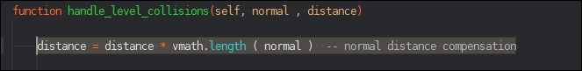

After looking further into the code of defold I uncovered that this ‘normal’ is a normalised vector. I first missed this as it wasn’t written into the documentation but later uncovered that it was a vector always equal to “1”. After learning this I realised that this line becamer obsolete and decided to get rid of it to lower storage and make the code more understandable to read.

Because the game doesn’t stay in one location I needed to create a camera object that would now follow the character whenever the user moved the character around the map. This allows me to have a large map that the character can walk through and have different enemies along the way.

This is added into the code to tell the game to follow the camera I’ve placed in as opposed to the inbuilt camera within the game. This uses some code that’s built into the editor to change the camera focus. Because this is built in and I havent made any changes to the code itself I decided to leave that part of the code out as I wasn’t the one who created it.

This part of the code is in the init function as it needs to be automatically done whenever the level is opened and doesn’t need to wait for the player to press an input.

First of all I added the camera game object in however I was unable to control its movement, I was able to fix this by using object oriented programming by creating a child of the “ hero “ called “ operator “ and adding the camera into this. This was also used to get the camera to follow the character as “ operator “ is a child of the hero it follows it movements anyway. I then changed the settings within the camera game model to mirror the aspect ratio of the screen used to play the game so the game would be in a rectangular format as opposed to a square. I also made the camera have an orthogrpahic projeciton. This will come in use later as it allows me to use a background and not have the background warped as the original camera view makes things that are further away smaller. I then lowered the zoom of the camera to have a big enough amount of the map I’d like to be shown in it.

## Creating the world

## Date : 17/03/24

Once I created the character and was able to make it move around I decided to create the level it would be traverssing. I decided to do this now as the character has been developed and I can test it within its environment to check if everything worls properly and to see if there are any bugs within the environement that the character can run into whilst playing.

The level design consisnts of the starting area ; this area has a part to the left that the character cant jump over, this is to make sure the character doesn’t fall out of the map and follows the correct route.

After the starting area there all some small yellow boxes, these will be used to implement the power-ups when they are ready to be coded. This is how the character will be able to get the power-ups by touching the boxes.

The floor and walls are very thick and take up lots of space, this is sp the player doesn’t see whats past these areas and makes the player feel like they are in a game instead of seeing past the game. They go up a large mountain and keep going up until they come to a large drop.

This is to show the player there is no turning back as they are unable to go anywhere else apart from down. At the bottom of the hole there will be the halfway checkpoint to show the player that they have gotten halfway. They go through a cave from then on that goes up and down and adds another smaller drop until they get into a large room. This is where they wil fight the mini-boss. This area is different to the rest of the area as it has a sort of purple grass to show the player that they are in the enemeis lair.

This is where the user and character will meet the mini-boss within the game and have to take it out. Before I go on with this kind of level design I will interview my client and show them how the level looks and if they want to change the design of the level in any way.

Interview plan 21/03/24

This interview will be conducted to see if the stakeholder, Rui Goncalves feels that the level desing is the same kind of design he had in mind and to see if there was anything that the stakehikder would like to add, get rid off or change within the level design.

Questions for the starting area

* Do you think the left hand of the screen should be blocked off to the player ?
  + If so should it be boxes that block off the player ?
* Should there be power-ups right at the player spawn point ?
* Should the spawn area be a grassy meadow ?
* Is there anything you would add to the spawn area ?

Questions for the mountain and fall

* Should the level go up a hill progressing into a mountain ?
* Should there be more power-ups up the hill ?
* Should the character fall into the hole ?
* Should the character be able to get back out of the hole ?
* Should there be anything added to this section of the game ?

Questions for the boss fight area

* Should there be a dedicated area to host the boss fight ?
* Should the boss fight area be a big room ?
* Is there anything you would add to the boss fight area ?

## Interview script 21/03/24

Starting area

Do you think the left hand of the screen should be blocked off to the player ?

I think it’s good to block off the left part of the starting area, this shows the user where the character needs to go in the game. This is good as it means that the users cant get confused on where to go because there is only one location that the character can actually go to

If so should it be boxes that block off the player ?

Out of everything within the tile map the boxes are the best thing to use to block off the left side of the screen. This shows that it isnt part of the environment and that the boxes are there for a reason to block off the user from going the wrong way.

Should there be power-ups right at the player spawn point ?

I think having the power-up box in the spawn area is good as it shows the user that the power-up boxes are good and should be used by the user whilst they play the game.

Should the spawn area be a grassy meadow ?

The grassy meadow shows that the spawn area is a nuetral area and gives the user time to relax before they start playing through the game against the enemies

Is there anything you would add to the spawn area ?

Theres nothing I’d add specifically to the spawn area however further throughout the level there are some things I’d like to add which I think would change how the user plays the level a bit.

Mountain and fall

Should the level go up a hill progressing into a mountain ?

I like how the level goes up the hill and shows the chaarcter progressing through the level instead of being on the same height the entire time

Should there be more power-ups up the hill ?

I do like the fact that there are more power-ups for the player to get as they progress through the level as they may not be expecting enemies and could need an extra help when starting the first level of the game

Should the character fall into the hole ?

I like how the character has to fall into the hole as it shows the level progressing, this is a good way to show to the user that the character is not only going into a different area but the new area has a completely different feeling as theres a different and darker terrain that will affetc how the user plays the level.

Should the character be able to get back out of the hole ?

I don’t think that the chararcter should be able to get out of the hole and I like that the halfway checkpoint will be at the bottom of the hole instead of being back at the top of the hole to convey to the user that there is no way back out of the area they have gone into

Should there be anything added to this section of the game ?

I think throughout the level there should be holes that the user can fall down and lose the game, I think there should be warnings between these holes and the hole that the user needs to go down as it could confuse the user and annoy them as they either go down the random holes in the floor or don’t go through the holes they need to go through.

Boss fight area

Should there be a dedicated area to host the boss fight ?

I like the fact that there is a dedicated area for the boss fight so the user knows that is different from the other enemies, I also like how the room looks different from the rest of the area that the player is in by showing that ther eis the purple grass texturre on the ground as opposed to the rest of the area where it is just stone. Not only is this different for the user to play but it also shwos that the mini-boss has effected the area with it’s power.

Should the boss fight area be a big room ?

I like the big room design as it feels like a real boss fight and that the mini-boss is stronger than the rest of the enemies that the user has defeated within the level.

Is there anything you would add to the boss fight area ?

I wouldn’t want to add the holes to the boss area as I believe that could be too difficult for the user however if there were some objects that were able to decorate the area that wouldn’t get in the way of the character I think it would look nice

## Updating the game level

## Date : 02/04/24

After having the interview with the client I have changed some things within the game level map, these changes are in line with what the client wanted for the level and adds more depth into the game. This means that the client will enjoy playing the game more. I then showed a video to the client of me walking through the level in which you can see here .

https://youtu.be/ZNun8ML4eEc

# EVALUATION

## Testing for evaluation

This section is testing the start up for the game, this involves opening up the game and the menu screen to show the user what game they are playing.

Start up

|  |  |  |  |  |  |
| --- | --- | --- | --- | --- | --- |
| **No**. | **Test** | **Input** | **Expected outcome** | **Actual outcome** | **Video reference** |
| 51. | A title screen is shown when the game is initialised | **N/A** | **Valid :** when the user opens the game the title screen is shown | **This feature was not implemented** | **N/A** |

A lot of the work and code that I created was done for the first time into such the depth that I was doing, due to this it took longer than expected to code each area as I had to learn how to create most of the things I was doing in Defold before I was able to implement them. Because of this there was a large delay in the development of the project and because the start up screen wasn’t something that was needed within the game it wasn’t something I had time to implement. Also to implement a start up screen speciffically for my game I would need the software capable of creating this. With some research I saw a way to do it but I would need to buy a subscription to be able to make use the service to create the start up screen.

If I had the time the start up screen would show the name of the game in large to make sure anyone could see. It would also have an options logo in the bottom right corner of the screen for the user to change the options before they get into the full game. The reason I would have the title screen so large is for any kind of person to be able to read what the game was called, I would also have the options in the corner so people can make any changes they may need such as acceisiblity changes before getting into the game. The user would be able to get past the title screen and into the game by clicking with the mouse to put the user into the menu screen.

Scoring

This section will test the scoring and scoreboard system within the game. This involves the score from each level, overall score for the game.

|  |  |  |  |  |  |
| --- | --- | --- | --- | --- | --- |
| **No**. | **Test** | **Input** | **Expected outcome** | **Actual outcome** | **Video reference** |
| 1. | The users final score is added to the scoreboard if it is greater than the score boards lowest score | **Valid :** a final score of 7856  **Invalid :** the string “hello” | **Valid :** the score is placed on the scoreboard next to the users name  **Invalid :** the string “hello” is displayed twice, once as score and once as name | **This feature was not implemented** | **N/A** |
| 2. | The username can be used for the scoreboard if the input is larger than 2 and smaller than 26 | **Valid :** the string “john”  **Invalid :** the string “1” | **Valid:** the string “john” is placed next to the users final score on the scoreboard  **Invalid :** the string “1” is placed next to the users final score on the scoreboard | **This feature was not implemented** | **N/A** |
| 3. | The user gains 10 score when an enemy is defeated | **Valid :** character defeats an enemy  **Invalid** : enemy defeats character | **Valid :** 10 points are added to the users score variable  **Invalid :** 230 points are taken from users score variable | **This feature was not implemented** | **N/A** |
| 4. | The user gains 50 score when a mini-boss is defeated | **Valid :** character defeats mini-boss  **Invalid :** character defeats enemy | **Valid :** 50 points are added to the users score variable  **Invalid** : 19 points are added to the users score variable | **This feature was not implemented** | **N/A** |
| 5. | The user gains 100 score when a boss is defeated | **Valid :** character defeats boss  **Invalid :** boss defeats character | **Valid :** 100 points are added to the users score variable  **Invalid :** 30 points are taken from the users score variable | **This feature was not implemented** | **N/A** |
| 48. | Score goes up during level | **N/A** | **Valid :** as the player gains points its shown on screen | **This feature was not implemented** | **N/A** |

The scoring and scoreboard system was never implemented into the game, this was also due to the time constraints within the project and the added development time due to the fact I had to research and learn. This would be created once the full game was made as an add-on to the game as opposed to its own separate thing to give the game more depth.

Screen elements

This section will test the screen elements that the user can see but character doesn’t interact with in the game, this involves the score, time, lives and scoreboard that shows once the game is over for all players.

|  |  |  |  |  |  |
| --- | --- | --- | --- | --- | --- |
| **No.** | **Test** | **Input** | **Expected outcome** | **Actual outcome** | **Video reference** |
| 6. | Score box in the top right of the screen | **N/A** | **Valid** : The score box is in the top right of the screen | **This feature was not implemented** | **N/A** |
| 7. | Timer in the top right of the screen | **N/A** | **Valid :** timer box in the top right of the screen | **This feature was not implemented** | **N/A** |
| 8. | Lives in the top left of the screen | **N/A** | **Valid :** lives in the top left of the screen | **This feature was not implemented** | **N/A** |
| 9. | Scoreboard is shown at the end of each game | **N/A** | **Valid :** scoreboard is shown at the end of each game | **This feature was not implemented** | **N/A** |

The score box , timer , lives and scoreboard wasn’t implemented into the game due to the same time constraints, this would be added into the game at the same time as the scoring system would be to add more depth to the game as opposed to being a critical part of the game.

Game navigation

This section will test the navigation through the game, this involves the game states including ; menu, settings, options, controls and accesibility options. This tests how the user can go through the game and explore each game state and menu area.

|  |  |  |  |  |  |
| --- | --- | --- | --- | --- | --- |
| **No.** | **Test** | **Input** | **Expected outcome** | **Actual outcome** | **Video reference** |
| 13. | Start level when level chosen | **N/A** | **Valid :** character starts level when level is chosen | **Works as expected** | https://youtu.be/ZNun8ML4eEc |
| 14. | Character moves on level state screen | **Valid :** input “d”  **Invalid :** input “3” | **Valid :** character moves right when “d” is pressed  **Invalid :** character moves left when “3” is pressed | **Works as expected** | https://youtu.be/ZNun8ML4eEc |
| 15. | Character choses level on level state screen | **N/A** | **Valid :** Choses correct level on level state screen | **This feature was not implemented** | **N/A** |
| 18. | Open options in menu | **N/A** | **Valid :** when the options button is clicked option menu opens | **This feature was not implemented** | **N/A** |
| 19. | Options is displayed | **N/A** | **Valid :** when options is opened options screen is displayed | **This feature was not implemented** | **N/A** |
| 20. | Accessibility options is displayed | **N/A** | **Valid :** when options is opened accessibility options screen is displayed | **This feature was not implemented** | **N/A** |
| 21. | Open controls menu | **N/A** | **Valid :** when the controls button is clicked controls open | **This feature was not implemented** | **N/A** |
| 22. | Controls is displayed | **N/A** | **Valid :** when controls is opened controls screen is displayed | **This feature was not implemented** | **N/A** |
| 23. | Change game controls | **Valid :** change “left” to “q”  **Invalid :** change “left” to “r2” | **Valid :** changes “left” control to “q”  **Invalid :** changes “left” control to “r2” | **This feature was not implemented** | **N/A** |
| 52. | Use the mouse to navigate the menu screen | **N/A** | **Valid :** when user moves mouse it moves on menu screen, also allows user to click buttons within menu | **This feature was not implemented** | **N/A** |

Lots of the other screens within this game apart from the game screen wasn’t implemented into the final product, with the time constraint the main thing that was needed to be created was the game itself which would allow the user to control the character along the level. This was more important to implement than the menu and option screens as this would actuallu allow the user to do something within the game.

Character

This section will test all of the features that reference the player, this includes player ; movement, damage, lives and animations. These tests are put in place to make sure the user can use the character as how was designed. This allows for a better playing experience for the user.

|  |  |  |  |  |  |
| --- | --- | --- | --- | --- | --- |
| **No.** | **Test** | **Input** | **Expected outcome** | **Actual outcome** | **Video reference** |
| 24. | Move the player | **Valid :** input “a” to move left  **Invalid :** input “8” to move left | **Valid :** when “a” is pressed player moves left  **Invalid :** when “8” is pressed player moves left | **Works as expected** | https://youtu.be/3_PzJq3p-4s |
| 25. | Make player jump | **Valid :** input “space” to jump  **Invalid :** input “g” to jump | **Valid :** when “space” is pressed character jumps  **Invalid :** when “g” is pressed character jumps | **Works as expected** | https://youtu.be/3_PzJq3p-4s |
| 32. | Character damage | **N/A** | **Valid :** when the character touches an enemies head hitbox the character does damage | **This feature was not implemented** | **N/A** |
| 36. | Character lives | **N/A** | **Valid :** when enemy does damage to character, character loses a life | **This feature was not implemented** | **N/A** |
| 39. | Character animation | **N/A** | **Valid :** A walking animation plays when character moves | **Works as expected** | https://youtu.be/3_PzJq3p-4s |
| 44. | Character lives go down when character receives damage | **N/A** | **Valid :** when the character receives damage the character lives deplete by 1 | **This feature was not implemented** | **N/A** |

The character was the main focus of the coding part of the project and was all working as I’d like it to, although the features that take lives from the character when damaged and it’s lives werent implemented with the current time constraint. This would be done soon as soon as I would be done with coding in the enemies I would code in the interactions between the enemies and the player.

Enemies

This section will test everything to do with the enemies, mini-boss and boss. This includes when the enemy should ; spawn, move, deal damage, lose lives and their animations. This is put in place to make sure all enemies within the game are coded as they should, this is to make sure the user not only has a fair fight any time they come across an enemy but also allows the user to have a fun time defeating the enemies.

|  |  |  |  |  |  |
| --- | --- | --- | --- | --- | --- |
| No. | Test | Input | Expected outcome | Actual outcome | Video reference |
| 26. | Spawn enemy | **N/A** | **Valid :** when in range of the character enemy spawns into the level | **This feature was not implemented** | **N/A** |
| 27. | Move enemy | **N/A** | **Valid :** when in range enemy moves toward character | **This feature was not implemented** | **N/A** |
| 28. | Spawn mini-boss | **N/A** | **Valid :** when in range of character mini-boss spawns into the level | **This feature was not implemented** | **N/A** |
| 29. | Move mini-boss | **N/A** | **Valid :** when in range mini-boss moves toward the character | **This feature was not implemented** | **N/A** |
| 30. | Spawn boss | **N/A** | **Valid :** when in range of character boss spawns into level | **This feature was not implemented** | **N/A** |
| 31. | Move boss | **N/A** | **Valid :** when in range boss moves toward the character | **This feature was not implemented** | **N/A** |
| 33. | Enemy damage | **N/A** | **Valid :** when the enemy touches the players hitbox the enemy does damage | **This feature was not implemented** | **N/A** |
| 34. | Mini-boss damage | **N/A** | **Valid :** when the mini-boss touches the players hitbox the mini-boss does damage | **This feature was not implemented** | **N/A** |
| 35. | Boss damage | **N/A** | **Valid :** when the boss touches the players hitbox the boss does damage | **This feature was not implemented** | **N/A** |
| 37. | Mini-boss lives | **N/A** | **Valid :** when character does damage to mini-boss, mini-boss loses a life | **This feature was not implemented** | **N/A** |
| 38. | Boss lives | **N/A** | **Valid :** when character does damage to boss, boss loses a life | **This feature was not implemented** | **N/A** |
| 40. | Enemy animation | **N/A** | **Valid :** a walking animation plays when enemy moves | **This feature was not implemented** | **N/A** |
| 41. | Mini-boss animation | **N/A** | **Valid :** a walking animation plays when mini-boss moves | **This feature was not implemented** | **N/A** |
| 42. | Boss animation | **N/A** | **Valid :** a walking animation plays when boss moves | **This feature was not implemented** | **N/A** |
| 45. | Mini-boss lives go down when mini-boss receives damage | **N/A** | **Valid :** when the mini-boss receives damage the mini-boss lives deplete by 1 | **This feature was not implemented** | **N/A** |
| 46. | Boss lives go down when boss receives damage | **N/A** | **Valid :** when the boss receives damage the boss lives deplete by 1 | **This feature was not implemented** | **N/A** |

Due to the considerable time constraints within the project development and the setbacks this section wa not imolpemented into the final game, these would be the next things I would make within the game however I’d need to get some more assets as there are no enemy sprites within the sprite pack I have.

Level mechanics

This section tests all of the mechanics that the user doesn’t see hidden within the level, this includes ; reason for a game over, timing and scoring. This is all tested so the level works smoothly. This also tests the reasons the game can be over to make sure the user doesn’t get stucck within the level.

|  |  |  |  |  |  |
| --- | --- | --- | --- | --- | --- |
| No. | Test | Input | Expected outcome | Actual outcome | Video reference |
| 10. | Game over when lives run out | **N/A** | **Valid :** game over when lives run out | **This feature was not implemented** | **N/A** |
| 11. | Game over when level complete | **N/A** | **Valid :** game over when level complete | **This feature was not implemented** | **N/A** |
| 12. | Game over when time runs out | **N/A** | **Valid :** game over when timer runs out | **This feature was not implemented** | **N/A** |
| 47. | Timer depletes during level | **N/A** | **Valid :** the timer goes down whilst the level is in progress | **This feature was not implemented** | **N/A** |
| 48. | Score goes up during level | **N/A** | **Valid :** as the player gains points its shown on screen | **This feature was not implemented** | **N/A** |

These werent implemented due to the time constraint however would be implemented once the character can take damage to end the game. The scoring and timer would be developled later on once the rest of the code is finhsed as more of an add-on to the game.

Whole game

This is testing to see if the game looks how it was supposed to be, this is all how the client wanted it to look like. This is tested to make sure that the client is happy with how the game looks before it is sent to them.

|  |  |  |  |  |  |
| --- | --- | --- | --- | --- | --- |
| No. | Test | Input | Expected outcome | Actual outcome | Video reference |
| 49. | Character and enemies are in a cartoon style | **N/A** | **Valid :** character and all enemies are in the cartoon style | **Partially implemented** | https://youtu.be/ZNun8ML4eEc |
| 50. | Background and level elements are in a cartoon style | **N/A** | **Valid :** the background and level elements are in a cartoon style | **Partially implemented** | https://youtu.be/ZNun8ML4eEc |

I believe I create the character and the enemies in the cartoon style that the client wanted however I didn’t implement a background or the enemies. This would be added on when I was able to find a sprite for the background or buy one. After having an interview with the client he is happy on the style of the game world and the style of the character.

## Usability features

Here I will annotate different images from the game that highlight the usability features incorporated into the game to help users. This will be followed by an explanation to the client Rui Goncalves as to why these features were added into the game and how they will help out specific consumers.

## Navigation

**Title screen**

**Image needed**

Although the title screen wasn’t complete in its entirety, I will explain what the title screen would’ve looked like if there were enough time to complete it. The title of the screen would be large and bold it the middle of the screen, this would allow users who find it hard to see well read the name of the game. Also in the bottom right corner of the screen would be a large gear image that signifies the settings option. This is easier that writing settings in the corner as its largely universal in video games that the gear means settings and options allowing the user to change the game settings how they want before they get into the main game state.

Me :

The purpose of the title screen is to show the user what game they are playing, I have also added the setting menu the user can click with their mouse to change settings from the title screen. Both the title and the settings icon would be large and visual. This would allow anyone with minor sight issues to see the screen without causing eye strain or bother

Rui Goncalves :

I remember speaking about usability features within the game and think this is a good way to implement them, I also see the gear picture as the settings as I play lots of other games that include that. I think making the title screen in this manor would be helpful to lots of people.

**Pause menu**

**Image needed**

The purpose of the pause menu state is to show the player the options, controls and new/load game screen. These would be in 3 large rows that show the user in large words what each one does, this again allows for users with sight issues to read what it says.

Me :

This is the pause menu state screen and shows the user the options, controls, and new/load game. I wanted all these pieces to be in the same place, so the user doesn’t need to go searching around the game trying to find out where to change things for them. It is all in one place which would make the game and the process more enjoyable and easier for the user making their playing experience better

Rui Goncalves :

I like the idea of all of the options to change how the game plays being in one place and being able to make a new game or load a game on the go however I feel it will be confusing to call the settings menu settings in one area and options in another even though they do the same thing in both places, I think it should either always be called options or always be called settings as changing from the both could confuse the user when they are trying to change the settings.

Me :

I realised that changing from options and settings would be confusing for lots of users, once implemented at all times the settings menu will be called settings as to not confuse the users.

**Settings menu**

**Image needed**

Although this has not yet been completed the settings menu will look much like the original pause menu having 3 larger boxes, these will be called ; options, accessibility options and back to menu. These will be clicked by the user with the mouse like the pause menu. The options will allow the user to change the options within the game such as the quality that the game is running in. These will all be in one place to make it easy for the user. Under this will be the accessibility options where users can change things such as the colourblind mode to allow colourblind user to play the game and make it easier for them. Lastly clicking the back to menu button will bring you back to the original pause menu, alternatively the user can press the “esc” key on the keyboard to bring them back to the original pause menu.

Me :

The settings menu will have 3 boxes like the pause menu each for options, accessibility options and going back to the pause menu screen, this will allow the user to change the options they like without getting confused on where to go and allow them to go back to the pause menu or using “esc”

Rui Goncalves :

It’s a good concept but I don’t think having menus in menus will work for users and they might seem lost. Instead, I think you should have all the settings in one area where the user can change them all. There should also be a prompt on the screen to press “esc” to leave the menu as opposed to having a physical button

Me :

With this in mind when this is implemented it will have all the options in one area and allow the user to scroll down through each one, the options will be titled and so will the accessibility options when the user scrolls down to it. Aswell as this there will be the “esc” button in the bottom left with the word exit next to it to show the player they must click “esc” to leave the settings menu.

**Controls menu**

**Image needed**

The controls menu will show the user the game controls with a picture of the keyboard and mouse and what each button does. It this area you are able to change the controls by pressing on a key on the keyboard or part of the mouse that you want to change to something else. This is also where you are able to plug in a third-party controller. This is to allow users who can’t play with a mouse and keyboard to still be able to play the game. This means more people can play the game when they wouldn’t normally be able to.

Me :

The controls screen will have a large visual of the controls with the keyboard and mouse that the user is able to change when they want, this menu will also allow the user to use a third-party controller that can help people who aren’t able to play with a conventional mouse and keyboard

Rui Goncalves :

I like how the controls are visual and that the user can see the keyboard and mouse, this means its easier for the user to change the controls whenever they want to. Aswell as this allowing the user to change and have a third-party controller will help many users that may have disabilities.

## Controls

The controls for the game are simple as the user can only go left , right , up and interact with things. This means the character playing only has 4 controls however going into the pause menu is “esc” and the user must control the mouse throughout the menu screens. These are very little controls for the user making the game much simpler for them.

Me : There are very few controls that the user must remember as there are only 4 in-game controls and “esc” to get onto the pause screen. Apart from this the only other control is moving the mouse around the pause menu. This is to make it easier for the user and means they don’t get confused on what they need to do. Therefore, making the game more enjoyable for them to play.

Rui Goncalves : I like how there are few keys and how you can do so much with the character whilst pressing so few keys, this makes it simpler for the user to play. I also like how these were able to be changed within the controls screen earlier in the evaluation.

## Screen elements

**score timer**

**lives**

Although this hasn’t been implemented these are where the lives, score and timer would go. This is used to show the user information about the game. The lives would show the user how many times they can take damage from an enemy before they are defeated. At the top right of the screen is the score that updates as the user does something that adds score onto it, this shows the user what they should do as when they do something that is good the score goes up. Next to that is the timer which shows the user how much time they have left to complete the level, this will tick down to 0 where the game ends or if the user finishes the level before the timer hits 0 the time left will be added onto the users score.

Me :

This is where the screen elements would be once implemented, the lives would show the user how many times they can be damaged by an enemy before the game is over and shown with a heart next to the number in the top left of the screen. The user would be able to gain more by getting the power-up if a life-up were to spawn. In the top right would be the score and the timer, these are placed together as they coincide with one another as once the character has finished the level the timer is added onto their score or the timer runs out and the level ends. The score updates in real time and gives the user points for activiites they do within the game.

Rui Goncalves :

I like how the lives are in the top left whereas the right is the timer and the score, it makes sense as to why they should be there. I also like the idea of the timer being added to the score once the level is finished as it gives more depth into the game and replayability. I do think putting them in the corners is good as it doesn’t clutter the screen to parts where the user will have to look for but still gives them enough room and space so the user can cleary see what they are.

## How well does the solution match the success criteria

The following section will be looking into all of the requirments that were stated in the research stage. I will be looking at how well the solution to the problem matches the requirements, this will also include any changes that were made to the originial design of the game during the development process and how I would have approached the completion of any unmet requirments if I were to carry it on in the future.

Start up

|  |  |  |
| --- | --- | --- |
| **No.** | **Requirements** | **Justification** |
| 1. | Title screen | This is made to show the user what game they are about to play |

This requirment was not met as there was no title screen, if given more time I would have implemented it by creating a visual screen for the user once they initiated the game, this would have the title of the game in large text clearly visible in the middle of the screen. At the bottom right of the screen would be an image of a cog that the user would be able to click to gain access to the settings menu. Anywhere else on the screen that they click would put them into the game.

To implement this I would need a software such as photoshop to create the images for the screen, aswell as this I would need to create a graphical user interface for the game. This would allow me to go from the title screen to the menu screen.

However this doesn’t effect gameplay at all and has a small effect on the whole game, due to this it would be one of the last things implemented into making the game as there are much more important things that should be implemented into the game first such as the enemies and damage.

Scoring

|  |  |  |
| --- | --- | --- |
| **No.** | **Requirements** | **Justification** |
| 9. | Point system | This is show at the top right of the screen and is made to help the user see what they should do and have a number of points for each level |
| 10. | Point overall | This will add all levels points at the end of the game for an overall and is made to show the user how well they did overall |
| 11. | Scoreboard | This will show the players points overall and is made so they can challenge their friends or other game saves. This helps with game replay ability |
| 14. | Timer link to points | This adds time remaining onto the points at the end of the level and is made to reward players who finish quickly |

This requirment was not met due to the time constraints and it not being a fundamental part of the game, however if I were to implement these features into the game it would include the points as a screen element. The points for each level would be saved into an external database, these would then be added once the game was over and shown to the player as their overall score. Another set of databases would be used for the scoreboard. There would be one for each level once the level was complete you can see where you are placed in the scoreboard. These would have 5 scores in with the players name which would be entered at the start of the game. These would have to be stored externally on a storage device that stays once the game has been closed.

This would be one of the last things implemented as it doesn’t have any impact to the gameplay, instead this is more for replayability and to see if you are better than your friends. However this would still be implemetned before the title screen as it does have some effect on how the users lpay the game.

Screen elements

|  |  |  |
| --- | --- | --- |
| **No.** | **Requirements** | **Justification** |
| 9. | Point system | This is show at the top right of the screen and is made to help the user see what they should do and have a number of points for each level |
| 12. | Timer | This will show in the top right of the screen and is made to show the user they have a certain amount of time to finish the level |
| 15. | Life system | This is shown at the top left of the screen and is made to show the user how many lives the character has left |

These requirments were not implemented, these wouldn’t have a large impact on gameplay however would still be useful for the player and would therefore be implemented soon within the game once the enemies had been implemented. If I were to implement these such as points I’d pick different actions that you could do in a game and give them each a points score. I would then check in real time if any of there actions had been done and everytime they were done they’d be added onto the points. These points would then be saved at the end of the game. To implement the timer each level would be given a different time limit, this would begin to countdonwn to 0, once getting to 0 the level would restart from the beginning, however if the timer didn’t get to 0 once the character touches the finishing flag the timer would stop and would be added to the level points. To implement the life system there would be a given amount of lives at the start, if an enemy touches the character anywhere but the bottom of it’s hitbox a life will be taken away. Once the lives are 0 the level restarts, to add more lives the character would have to get into contact with a power-up box. This would add a life onto the characters total. Each level the lives from the level before would be brought over from the level beforehand, this would make keeping lives more meaningful for the user as it helps them out further into the game.

Game navigation

|  |  |  |
| --- | --- | --- |
| **No.** | **Requirements** | **Justification** |
| 2. | Menu system | This is made so the user has all options and games in one place |
| 3. | Options / Settings | This will be in the menu and is made to allow the user to change settings as part of the game |
| 4. | Controls options | This will be part of the menu in settings and is made so the user can see what each control does and allows the user to change any controls |
| 5. | Accessibility options | This is part of the options and allows the user to choose accessibility options that will help them within the game |
| 6. | Create / Load game | This is in the main menu screen and menu system and allows the user to create a new game or load an existing game save |
| 30. | Level to level movement | This is added to show the user the character moving from each level to the next |

These were not implemented into the final game, much of this is options and menus which helps with how the user plays the game such as accesibility options, if I were to implement these I would use photoshop to create the menu screens. These would be opened by the click of the “esc” and then the user would use the mouse to navigate through the menu. The level to level movement would be done within a separate level that would show the character going from each level to the other, this is where you would be able to see the scores from each level.

Character

|  |  |  |
| --- | --- | --- |
| **No.** | **Requirements** | **Justification** |
| 16. | Regain lives | Once the character runs out of lives they are kicked out of the level and made to start again, this is made so the user can’t play too aggressively |
| 17. | Power up / Life up | This is added to help out the player throughout each level and can give the player a power up to help defeat enemies or more lives |
| 19. | Keyboard controls | This is added to control the characters movement |
| 20. | Mouse controls | This is added to control the character using power ups |
| 24. | How to eliminate enemies | This is added to eliminate enemies in which you jump on their head |

This section was partially implemented as I was able to create the keyboard controls, because the power-ups werent implemented into the game I didn’t need to create mouse controls. However if I were able to once creating the power-up boxes where the character can either gain a life which ive explained how I’d or gain a power-up this would be something such as a thrown attack where the user would click the mouse button to activate it. This would be on a timer and the user would go back to normal once the timer was over. To implement the mouse controls this would be done like the keyboard controls were done shown in the project diary. To eliminate the enemies the game would check if the botttom of the character’s hitbox where to touch the top of the enemies hit box. If this were to happen the enemy would be eliminated and disappear from the level.

Enemies

|  |  |  |
| --- | --- | --- |
| **No.** | **Requirements** | **Justification** |
| 21. | Enemies | These are added as a challenge the player must defeat |
| 22. | Amount of enemies | This is added to have a set number of enemies in each level fore the player to eliminate |
| 23. | Enemy types | Different enemy types are added to change up the gameplay for the user |
| 25. | How enemies eliminate character | This is added for enemies to eliminate the character if they touch the character |
| 26. | Main boss | This is added to give a big ending to the game and make the user feel accomplished |
| 27. | Mini boss | This is added to have a boss fight part way through the game and introduce the user to the boss type enemy |

There were not implemented, however they would be the next step of the coding project. To implement these I would create a character such as I did with the player character. However this character would be coded to follow the character within a certain radius. This could be done by chcking the character x and y position until it gets closer to the enemy and have the enemy go to the characters x and y position and keep refreshing for the new location in turn following the character. The enemies would be defeated once the character did damage to them but with the mini-boss and the boss they would have a health pool similar to the characters and would need the character to do damage to them multiple times until their health turned to 0 in turn eliminating them too.

Level mechanics

|  |  |  |
| --- | --- | --- |
| **No.** | **Requirements** | **Justification** |
| 7. | Background progressing from meadow to sewer | The background will change throughout the game to show the user the progression they have made |
| 8. | Terrain progressing from meadow to sewer | This will follow the background change and is made to show the user their progression throughout the game |
| 9. | Point system | This is show at the top right of the screen and is made to help the user see what they should do and have a number of points for each level |
| 10. | Point overall | This will add all levels points at the end of the game for an overall and is made to show the user how well they did overall |
| 11. | Scoreboard | This will show the players points overall and is made so they can challenge their friends or other game saves. This helps with game replay ability |
| 12. | Timer | This will show in the top right of the screen and is made to show the user they have a certain amount of time to finish the level |
| 13. | Level fail screen | This screen is shown if a user runs out of lives or time and is made to show they have lost |
| 14. | Timer link to points | This adds time remaining onto the points at the end of the level and is made to reward players who finish quickly |
| 18. | Fail level screen | This is added to tell the player they’ve lost and shows when they run out of lives or time |
| 28. | Halfway checkpoint | This is added to help the user instead of having to respawn at the start of each level |
| 29. | Finish point | This is added to show the user a clear finishing point to each level |

Some of these requirments were implemented such as the terrain progression, however the rest was not. If I were to implement these I would create the background by creating another layer on the level design that the character can’t interact with and would be sat behind the layer the character is on. The points system scoreboard and timer I have already spoke on how I would implement. For the level fail screen this would be produced once the character lives were equal to 0 or the level timer ran out. Once this happened it would be a screen similar to the settings screeen with the options to quit to the main menu or start the level again from the start. The halfway checkpoint and the end checkpoint would be most difficult to implement. The halfway checkpoint would be triggered once the hcaracter corssses thee checkpoints x-axis. Once this happens anytime the character needs to respawn the character would change the spawn point to the halfway point. To get the final checkpoint to work once the character crossed its x-axis the level technically were to end. This is because it would tell all enemies and the timer to stop whilst it plays a level finish animation. This would then take the player out of th level and back into the level select screen.

This would be implemented once the enemies were created into the game allow the character to finish a level or be diefeated and have to restart the level. This does effect gameplay strongly as it is a big part of the game.

## Maintenance

Current and future maintenance

I havent implemented any maintenancew features into the game but if this where introduced for a large audience this would have to be done . This would handle bug fixes and updates by adding more features.

This solution is not finished but upon completion I would add a feature into the game that would tell the user there is an update on the title screen. This would allow the user to update the game and run on the new version that would have the fixes to the bugs implemented or more content added to the game. This could be done by me or a team of people who have knowledge on Defold to create a game that the players like to play.

One way the game could need maintenance is if one of the libraries I was using were to be taken offline as the game would no longer be able to run without an error. This would have to be fixed by creating the code from the library for the game alone instead of in a library that people can use when creating a game.

## Limitations and how they would be approached

The following consists of a series of possible limitations to the game and how they could be approached.

|  |  |
| --- | --- |
| Requirment | Justification |
| Add enemies, mini-boss and boss | This would be done to give the user a challenge to play agiainst. The reason for different kinds of enemies is to make sure it doesn’t get repetitive. |

To complete this requirment I would need more sprites that would be able to function as eneimies, a mini-boss and a boss. These would be done so the user doesn’t get confused between these and the character and it cleary shows who is who. These would also need to be able to move and damage the player without user input and would need to be able to be defeated once the player defeats them.

|  |  |
| --- | --- |
| Requirment | Justification |
| Allow the user to use a third-party controller | This is used to help users that have accesibility issues or disabilites which means they can’t use a mouse and keyboard |

To implement this requirment I would have to find or make additional software that is able to port and display a third part controller. This software would also mean the third-party controller would be able to be used within the game ands recognised in this sense to allow the user to change controls.

|  |  |
| --- | --- |
| Requirments | Justification |
| Allow the user to play 2 player locally | This would allow the user to play with another person on the same system as 2 different characters |

This would be implemeted by finding or creating the software that is capable of taking a secondary input from the system. It would also need to create a second character for the other player to control and save the informatiom along with that character such as lives.

|  |  |
| --- | --- |
| Requirments | Justification |
| Impressive visuals | This will make the game more appealing to a wider audience |

To implement this requirment I would need additional software, this would allow me to add lighting effects and shadows into the game and make it look more pleasing to the viewer. Aswell as this I would need to add an option to lower the graphics to give the user a smaller load on there graphics card if those were unable to support the visuals.

# PROJECT APPENDIXES

## Code listing

